UNITED STATES
SECURITIES AND EXCHANGE COMMISSION
Washington, D.C. 20549
FORM 8-K
CURRENT REPORT
PURSUANT TO SECTION 13 OR 15(D) OF THE SECURITIES EXCHANGE ACT OF 1934
Date of Report (Date of earliest event reported): August 14, 2026
Commission File Number 1-13610
CREATIVE MEDIA & COMMUNITY TRUST CORPORATION
(Exact name of registrant as specified in its charter)
Maryland |  |  |  |  |  |  |  |  |  |  |  | 75-6446078
(State or Other Jurisdiction of  Incorporation or Organization) |  |  |  |  |  |  |  |  |  |  |  | (I.R.S. Employer  Identification No.)
4700 Wilshire Boulevard, Los Angeles, CA 90010 |  |  |  |  |  |  |  |  |  |  |  | (866) 242-1266
(Address of Principal Executive Offices) |  |  |  |  |  |  |  |  |  |  |  | (Registrant's telephone number)
None
(Former name or former address, if changed since last report)
Check the appropriate box below if the Form 8-K filing is intended to simultaneously satisfy the filing obligation of the registrant under any of the following provisions:
☐ Written communications pursuant to Rule 425 under the Securities Act (17 CFR 230.425)
☐ Soliciting material pursuant to Rule 14a-12 under the Exchange Act (17 CFR 240.14a-12)
☐ Pre-commencement communications pursuant to Rule 14d-2(b) under the Exchange Act (17 CFR 240.14d-2(b))
☐ Pre-commencement communications pursuant to Rule 13e-4(c) under the Exchange Act (17 CFR 240.13e-4(c))
Securities Registered Pursuant to Section 12(b) of the Act:
Title of each class |  |  |  |  |  | Trading Symbol(s) |  |  |  |  |  | Name of each exchange on which registered
Common Stock, $0.001 Par Value |  |  |  |  |  | CMCT |  |  |  |  |  | The Nasdaq Stock Market LLC
Indicate by check mark whether the registrant is an emerging growth company as defined in Rule 405 of the Securities Act of 1933 (§230.405 of this chapter) or Rule 12b-2 of the Securities Exchange Act of 1934 (§240.12b-2 of this chapter).
Emerging growth company ☐
If an emerging growth company, indicate by check mark if the registrant has elected not to use the extended transition period for complying with any new or revised financial accounting standards provided pursuant to Section 13(a) of the Exchange Act ☐

Item 2.02 Results of Operations and Financial Condition
On August 14, 2026 Creative Media & Community Trust Corporation (the “Company”) issued a press release announcing its financial results for the period ended June 30, 2026. A copy of the press release is attached to this Form 8-K as Exhibit 99.1 and is incorporated by reference herein.
The information in this Item 2.02 and Exhibit 99.1 are being furnished and shall not be deemed “filed” for the purposes of Section 18 of the Securities Exchange Act of 1934, as amended (the “Exchange Act”), or otherwise subject to the liabilities of that Section, nor shall it be deemed incorporated by reference into any filing of the Company under the Securities Act of 1933, as amended (the “Securities Act”), or the Exchange Act, whether made before or after the date hereof, regardless of any general incorporation language in such filing.

Item 7.01. Regulation FD Disclosure
A copy of the Company’s Q2 2026 Shareholder Presentation is attached to this Form 8-K as Exhibit 99.2 and is incorporated by reference herein. Additionally, the Company has posted a copy of the presentation on its Shareholder Relations page at www.creativemediacommunity.com.
The information in this Item 7.01 and Exhibit 99.1 of this Current Report shall not be deemed to be filed for purposes of Section 18 of the Securities Exchange Act of 1934, as amended (the “Exchange Act”), or otherwise subject to the liabilities of that section, nor shall it be deemed incorporated by reference in any registration statement or other filing under the Securities Act of 1933, as amended, or the Exchange Act, except in the event that the Company expressly states that such information is to be considered filed under the Exchange Act or incorporates it by specific reference in such filing.

Item 9.01 Financial Statements and Exhibits.

Exhibit Number |  |  |  |  |  | Exhibit Description
*99.1 |  |  |  |  |  | Press Release dated August 14, 2026 regarding the Company’s financial results for the quarter ended June 30, 2026
*99.2 |  |  |  |  |  | Shareholder Presentation for Q2 2026
104 |  |  |  |  |  | Cover Page Interactive Data File (embedded within the Inline XBRL document).
*Filed herewith

SIGNATURE
Pursuant to the requirements of the Securities Exchange Act of 1934, the Registrant has duly caused this report to be signed on its behalf by the undersigned thereunto duly authorized.
 |  |  |  |  |  | CREATIVE MEDIA & COMMUNITY TRUST CORPORATION
Dated: August 13, 2026 |  |  |  |  |  | By: |  |  |  |  |  | /s/ Brandon Hill  Brandon Hill  Chief Financial Officer and Treasurer

Exhibit 99.1



Creative Media & Community Trust Corporation Reports 2026 Second Quarter Results
Los Angeles—(August 14, 2026) Creative Media & Community Trust Corporation (NASDAQ: CMCT) (“we”, “our”, “CMCT”, or the “Company”) today reported operating results for the three months ended June 30, 2026.
On March 26, 2026, the Company effected a 1-for-10 reverse stock split on the Company’s Common Stock, par value $0.001 per share (the “Common Stock”), and on April 20, 2026, the Company effected a 1-for-10 reverse stock split on its Common Stock. All of the share and per share amounts in this release have been adjusted to give retroactive effect to the reverse stock splits (collectively, the “Reverse Stock Splits”).

Second Quarter 2026 Highlights
Real Estate Portfolio
•CMCT’s office portfolio was 72.3% leased as of June 30, 2026 (84.4% leased as of June 30, 2026 compared to 79.7% leased as of June 30, 2025, when excluding our one Oakland office building (the “Oakland Office Building”)).
•Executed 16,176 square feet of leases with terms longer than 12 months.
•CMCT’s same-store multifamily portfolio occupancy was 95.3% as of June 30, 2026, representing a 1,190 basis point improvement from the second quarter of 2025.
Financial Results
•Net loss attributable to common stockholders of $(11.0) million, or $(4.03) per diluted share.
•Funds from operations attributable to common stockholders (“FFO”)(3)1 was $(3.5) million, or $(1.28) per diluted share.
•Core FFO attributable to common stockholders (“Core FFO”)(4)1 was $(3.4) million, or $(1.25) per diluted share.
•Undepreciated common book value(10)1 was $130.58 per share of Common Stock.

Management Commentary
Operating trends continue to improve across the multifamily portfolio, the Los Angeles and Austin office assets and the Company’s one hotel, and we continue to evaluate the potential sale of one or more of our real estate assets.
Total segment net operating income decreased (5.2)% to $9.3 million for the three months ended June 30, 2026, compared to $9.8 million for the same period in 2025. However, total segment net operating income, exclusive of loss from unconsolidated entities (“NOI, exclusive of loss from unconsolidated entities”)(11)1, increased 22.2% to $12.5 million for the three months ended June 30, 2026, compared to $10.3 million for the same period in 2025, as this measure excludes the impact of real estate valuation adjustments recognized by the Company’s unconsolidated entities during the period.
Operating Trends
Multifamily
78% of CMCT’s multifamily portfolio (based on the number of units) is in the Bay Area, where the residential market is rapidly improving.
CMCT’s same-store multifamily occupancy was 95.3% as of June 30, 2026, representing a 1,190 basis point improvement from the second quarter of 2025.
In-place rents at CMCT’s Bay Area multifamily assets are approximately 12% below current asking rents, providing an opportunity to grow net operating income as new leases are increased to market.
Office
In the office segment, excluding the Oakland Office Building, the leased percentage was 84.4% as of June 30, 2026, representing a 470 basis point improvement from the second quarter of 2025.
1Non-GAAP financial measure. Refer to the explanations and reconciliations elsewhere in this release.
Exhibit 99.1

1

At 11600 Wilshire Boulevard, the Company recently completed its renovation program, which is anticipated to improve leasing activity. The Company is also seeing steady leasing interest at its Culver City and Austin creative office assets.
The Company owns one office asset in Oakland, where demand continues to be challenging. The non-recourse mortgage on the Oakland Office Building matured in the third quarter of 2026. The Company elected not to invest the additional capital in the asset that would have been required to refinance the mortgage and continues to engage with the servicer on a long-term resolution.

Hotel
In the hotel segment, the Company has substantially completed the renovation of the public space, following the renovation of all 505 rooms, setting the property up well for 2026 and beyond. The renovation was the first large scale renovation of the property since it was acquired in 2008. The Company is also exploring an opportunity to convert underutilized space into eight additional rooms.

Improved Financial Strength
The Company has made significant progress on its plan to accelerate its focus towards premier multifamily assets, strengthen the balance sheet and improve liquidity.
Since announcing this plan in September 2024, the Company has completed financings on nine assets, fully retired its recourse credit facility, sold its lending business and redeemed approximately $397.7 million of preferred stock of the Company (“Preferred Stock”) in exchange for shares of Common Stock.
In addition, the Company continues to evaluate the potential sale of one or more of our real estate assets.
Given the Company’s improved financial position, the Company does not currently intend to redeem, at the Company’s election, additional Preferred Stock in shares of Common Stock. However, the Company will evaluate redemption requests submitted by holders of Preferred Stock at the time it receives such requests and may elect to redeem those Preferred Shares in Common Stock or cash, at the Company’s discretion.

Second Quarter 2026 Results
Real Estate Portfolio
As of June 30, 2026, our real estate portfolio consisted of 27 assets, all of which were fee-simple properties and five of which we own through investments in unconsolidated joint ventures. Our unconsolidated joint ventures contain one office property, three multifamily properties (one of which has been partially converted from office into multifamily units and is now classified as a multifamily property) and one commercial development site. As of June 30, 2026, our 12 office properties, totaling approximately 1.3 million rentable square feet, were 71.9% occupied; our one hotel with an ancillary parking garage, which has a total of 505 rooms, had RevPAR of $180.47 for the three months ended June 30, 2026, and our five multifamily properties were 93.6% occupied. Additionally, as of June 30, 2026, we had eight development sites (two of which were being used as parking lots).
Financial Results
Net loss attributable to common stockholders was $(11.0) million, or $(4.03) per diluted share of Common Stock, for the three months ended June 30, 2026, compared to a net loss attributable to common stockholders of $(14.3) million, or $(1,784.88) per diluted share of Common Stock, for the same period in 2025. The decrease in net loss attributable to common stockholders was primarily driven by a decrease in redeemable preferred stock dividends of $4.3 million, partially offset by a decrease in segment net operating income of $510,000.
FFO(3)2 was $(3.5) million, or $(1.28) per diluted share of Common Stock, for the three months ended June 30, 2026, compared to $(7.9) million, or $(981.63) per diluted share of Common Stock, for the same period in 2025. The increase in FFO2 was primarily attributable to a decrease in redeemable preferred stock dividends of $4.3 million, and a decrease in transaction-related costs of $786,000, partially offset by a decrease in segment net operating income of $510,000.
Core FFO(4)2 was $(3.4) million, or $(1.25) per diluted share of Common Stock, for the three months ended June 30, 2026, compared to $(7.0) million, or $(870.25) per diluted share of Common Stock, for the same period in 2025. The increase in Core FFO2 is primarily attributable to the aforementioned changes in FFO2. Unlike FFO2, Core FFO2 was not impacted by the aforementioned decrease in transaction-related costs, as these are excluded from our Core FFO2 calculation.
2 Non-GAAP financial measure. Refer to the explanations and reconciliations elsewhere in this release.

2
Segment Information
Our reportable segments during the three months ended June 30, 2026 and 2025 consisted of three types of commercial real estate properties, namely, office, hotel and multifamily. Total segment net operating income (“NOI”)(5) was $9.3 million for the three months ended June 30, 2026, compared to $9.8 million for the same period in 2025.
Office
Same-Store
Same-store(2) office segment NOI(5) was $4.0 million for the three months ended June 30, 2026 compared to $5.5 million for the three months ended June 30, 2025, while same-store(1) office Cash NOI(6)3 was $4.1 million for the three months ended June 30, 2026, a decrease from $5.8 million in the same period in 2025. The change in same-store(2) office segment NOI(5) and same-store(1) office Cash NOI(6)3 was primarily driven by fair value adjustments to real estate at two of our unconsolidated office entities during the three months ended June 30, 2026. The change was partially offset by an increase in rental revenue and tenant reimbursement revenue, together with a decrease in real estate taxes and administrative costs at office properties in Los Angeles, California, as well as an increase in tenant reimbursement revenue at the Oakland Office Building and a decrease in administrative costs at an office property in Austin, Texas during the three months ended June 30, 2026 compared to the three months ended June 30, 2025.
At June 30, 2026, the Company’s same-store(2) office portfolio was 71.9% occupied, an increase of 380 basis points year-over-year on a same-store(2) basis, and 72.3% leased, an increase of 220 basis points year-over-year on a same-store(2) basis. The annualized rent per occupied square foot(7) on a same-store(2) basis was $58.69 at June 30, 2026, compared to $60.96 at June 30, 2025. During the three months ended June 30, 2026, the Company executed 16,176 square feet of leases with terms longer than 12 months at our same-store(2) office portfolio.
Total
Office Segment NOI(5) was $4.0 million for the three months ended June 30, 2026 compared to $5.5 million for the three months ended June 30, 2025, driven by the aforementioned offsetting activity impacting the same-store(2) office Segment NOI(5).
Hotel
Hotel Segment NOI(5) was $4.6 million for the three months ended June 30, 2026, as compared to $4.2 million for the same period in 2025. The increase was attributable to increases in room revenue and food and beverage revenues, partially offset by increases in food and beverage expenses and room expenses, as a result of increased occupancy for the three months ended June 30, 2026, compared to the three months ended June 30, 2025, in addition to an increase in general and administrative expenses compared to the prior year period.
 |  |  |  |  |  | Three Months Ended June 30,
 |  |  |  |  |  | 2026 |  |  |  |  |  | 2025
Occupancy |  |  |  |  |  | 80.7 |  | % |  |  |  | 78.4 |  | %
Average daily rate(a) |  |  |  |  |  | $ | 223.67 |  |  |  |  | $ | 212.92
Revenue per available room(b) |  |  |  |  |  | $ | 180.47 |  |  |  |  | $ | 166.83
______________________
(a)Calculated as trailing 3-month room revenue divided by the number of rooms occupied.
(b)Calculated as trailing 3-month room revenue divided by the number of available rooms.
Multifamily
Our Multifamily Segment consists of two multifamily buildings located in Oakland, California as well as three investments in multifamily buildings in Los Angeles, California owned through unconsolidated joint ventures. Our multifamily segment NOI(5) increased to $638,000 for the three months ended June 30, 2026, compared to $189,000 for the same period in 2025. As of June 30, 2026, our Multifamily Segment was 93.6% occupied, monthly rent per occupied unit(8) was $2,560 and net monthly rent per occupied unit(9) was $2,286, compared to 83.4%, $2,458, and $2,284, respectively, as of June 30, 2025.
3 Non-GAAP financial measure. Refer to the explanations and reconciliations elsewhere in this release.

3
Debt and Equity
During the three months ended June 30, 2026, the Company redeemed 22,035 shares of Series A1 Preferred Stock and 39,266 shares of Series A Preferred Stock (all shares of which were redeemed in shares of Common Stock). These redemptions resulted in the collective issuance of 308,679 shares of Common Stock during the three months ended June 30, 2026.

As of June 30, 2026, the non-recourse mortgage on the Company's Oakland Office Building had an outstanding balance of $97.1 million. The mortgage matured in the third quarter of 2026. The Company elected not to invest additional capital in the asset that would have been required to refinance the mortgage. The Company continues to engage with the special servicer on a long-term resolution.
We are in discussions with a lender related to the Sheraton Hotel to refinance the asset, which we expect to result in an upsized loan and a reduced interest rate.

Dividends
We declared preferred stock dividends on our Series A, Series A1 and Series D Preferred Stock for the second quarter of 2026. The dividends were payable on July 15, 2026 to holders of record at the close of business on July 5, 2026.
The dividend amounts are as follows:
 |  |  | Quarterly Dividend Amount
Series A Preferred Stock |  |  | $0.34375 per share
Series A1 Preferred Stock |  |  | $0.38375 per share*
Series D Preferred Stock |  |  | $0.353125 per share
*The quarterly cash dividend of $0.38375 per share represents an annualized dividend rate of 6.14% (2.5% plus the federal funds rate of 3.64% on the applicable determination date). The terms of the Series A1 Preferred Stock provide for cumulative cash dividends (if, as and when authorized by the Board of Directors) on each share of Series A1 Preferred Stock at a quarterly rate of the greater of (i) 6.00% of the Series A1 Stated Value, divided by four (4) and (ii) the Federal Funds (Effective) Rate on the applicable determination date, plus 2.50%, of the Series A1 Stated Value, divided by four (4), up to a maximum of 2.50% of the Series A1 Stated Value per quarter.

About the Data
Descriptions of certain performance measures, including Segment NOI, Cash NOI, FFO attributable to common stockholders, Core FFO attributable to common stockholders, undepreciated common book value, and NOI, exclusive of income (loss) from unconsolidated entities are provided below. Certain of these performance measures—Cash NOI, FFO attributable to common stockholders, Core FFO attributable to common stockholders, undepreciated common book value, and NOI, exclusive of income (loss) from unconsolidated entities —are non-GAAP financial measures. Refer to the subsequent tables for reconciliation of these non-GAAP financial measures to the most directly comparable GAAP financial measure.
(1)Stabilized office portfolio: represents office properties where occupancy was not impacted by a redevelopment or repositioning during the period.
(2)Same-store properties: are properties that we have owned and operated in a consistent manner and reported in our consolidated results during the entire span of the periods being reported. We excluded from our same-store property set this quarter any properties (i) acquired on or after April 1, 2025; (ii) sold or otherwise removed from our consolidated financial statements on or before June 30, 2026; or (iii) that underwent a major repositioning project we believed significantly affected its results at any point during the period commencing on April 1, 2025 and ending on June 30, 2026.
(3)FFO attributable to common stockholders (“FFO”): represents net income (loss) attributable to common stockholders, computed in accordance with GAAP, which reflects the deduction of redeemable preferred stock dividends accumulated, excluding gain (or loss) from sales of real estate, impairment of real estate, casualty losses, net, and real estate depreciation and amortization. We calculate FFO in accordance with the standards established by the National Association of Real Estate Investment Trusts (the “NAREIT”). See ‘Core FFO’ definition below for discussion of the benefits and limitations of FFO as a supplemental measure of operating performance.
(4)Core FFO attributable to common stockholders (“Core FFO”): represents FFO attributable to common stockholders (computed as described above), excluding gain (loss) on early extinguishment of debt, redeemable preferred stock deemed dividends, redeemable preferred stock redemptions, gain (loss) on termination of interest rate swaps, and transaction costs.
We believe that FFO is a widely recognized and appropriate measure of the performance of a REIT and that it is frequently used by securities analysts, investors and other interested parties in the evaluation of REITs, many of which present FFO

4
when reporting their results. In addition, we believe that Core FFO is a useful metric for securities analysts, investors and other interested parties in the evaluation of our Company as it excludes from FFO the effect of certain amounts that we believe are non-recurring, are non-operating in nature as they relate to the manner in which we finance our operations, or transactions outside of the ordinary course of business.
Like any metric, FFO and Core FFO should not be used as the only measure of our performance because it excludes depreciation and amortization and captures neither the changes in the value of our real estate properties that result from use or market conditions nor the level of capital expenditures and leasing commissions necessary to maintain the operating performance of our properties, and Core FFO excludes amounts incurred in connection with non-recurring special projects, prepaying or defeasing our debt, repurchasing our preferred stock, and adjusting the carrying value of our preferred stock classified in temporary equity to its redemption value, all of which have real economic effect and could materially impact our operating results. Other REITs may not calculate FFO and Core FFO in the same manner as we do, or at all; accordingly, our FFO and Core FFO may not be comparable to the FFOs and Core FFOs of other REITs. Therefore, FFO and Core FFO should be considered only as a supplement to net income (loss) as a measure of our performance and should not be used as a supplement to or substitute measure for cash flows from operating activities computed in accordance with GAAP. FFO and Core FFO should not be used as a measure of our liquidity, nor is it indicative of funds available to fund our cash needs, including our ability to pay dividends. FFO and Core FFO per share for the year-to-date period may differ from the sum of quarterly FFO and Core FFO per share amounts due to the required method for computing per share amounts for the respective periods. In addition, FFO and Core FFO per share is calculated independently for each component and may not be additive due to rounding.
(5)Segment NOI: for our real estate segments represents rental and other property income and expense reimbursements less property related expenses and excludes non-property income and expenses, interest expense, depreciation and amortization, corporate related general and administrative expenses, gain (loss) on sale of real estate, gain (loss) on early extinguishment of debt, impairment of real estate, transaction costs, and benefit (provision) for income taxes. For our lending segment, Segment NOI represents interest income net of interest expense and general overhead expenses. See ‘Cash NOI’ definition below for discussion of the benefits and limitations of Segment NOI as a supplemental measure of operating performance.
(6)Cash NOI: for our real estate segments, represents Segment NOI adjusted to exclude the effect of the straight lining of rents, acquired above/below market lease amortization and other adjustments required by generally accepted accounting principles (“GAAP”). For our lending segment, there is no distinction between Cash NOI and Segment NOI.
Segment NOI and Cash NOI are not measures of operating results or cash flows from operating activities as measured by GAAP and should not be considered alternatives to income from continuing operations, or to cash flows as a measure of liquidity, or as an indication of our performance or of our ability to pay dividends. Companies may not calculate Segment NOI or Cash NOI in the same manner. We consider Segment NOI and Cash NOI to be useful performance measures to investors and management because, when compared across periods, they reflect the revenues and expenses directly associated with owning and operating our properties and the impact to operations from trends in occupancy rates, rental rates and operating costs, providing a perspective not immediately apparent from income from continuing operations. Additionally, we believe that Cash NOI is helpful to investors because it eliminates straight line rent and other non-cash adjustments to revenue and expenses.
(7)Annualized rent per occupied square foot: represents gross monthly base rent under leases commenced as of the specified periods, multiplied by twelve. This amount reflects total cash rent before abatements. Where applicable, annualized rent has been grossed up by adding annualized expense reimbursements to base rent. Annualized rent for certain office properties includes contractual rent under retail leases.
(8)Monthly rent per occupied unit: Represents gross monthly base rent under leases commenced as of the specified period, divided by occupied units. This amount reflects total cash rent before concessions.
(9)Net monthly rent per occupied unit: Represents gross monthly base rent under leases commenced as of the specified period less rent concessions granted during the specified period, divided by occupied units.
(10)Undepreciated common book value: Represents total stockholders’ equity, computed in accordance with GAAP, adjusted to exclude accumulated depreciation and preferred stock. We believe that undepreciated common book value is a useful metric for securities analysts, investors and other interested parties in the evaluation of our Company as it excludes from common stockholder’s equity the effect of depreciation, which is a non-cash expense.
(11)NOI, exclusive of income (loss) from unconsolidated entities: Represents Segment NOI, as defined above, adjusted to exclude our share of income (loss) from unconsolidated entities. We believe this measure is useful for the current period because it reflects the operating performance of our consolidated real estate portfolio without the impact of one-time real estate valuation adjustments recognized by unconsolidated entities during the period.

5
FORWARD-LOOKING STATEMENTS
This press release contains certain forward-looking statements within the meaning of Section 27A of the Securities Act of 1933, as amended, and Section 21E of the Securities Exchange Act of 1934, as amended, which are intended to be covered by the safe harbors created thereby. These statements include the plans and objectives of management for future operations, including plans and objectives relating to future growth of CMCT’s business and availability of funds. Such forward-looking statements can be identified by the use of forward-looking terminology such as “may,” “will,” “project,” “target,” “expect,” “intend,” “might,” “believe,” “anticipate,” “estimate,” “could,” “would,” “continue,” “pursue,” “potential,” “forecast,” “seek,” “plan,” “should” or “goal” or the negative thereof or other variations or similar words or phrases. Such forward-looking statements also include, among others, statements about CMCT’s plans and objectives relating to future growth and outlook. Such forward-looking statements are based on particular assumptions that management of CMCT has made in light of its experience, as well as its perception of expected future developments and other factors that it believes are appropriate under the circumstances. Forward-looking statements are necessarily estimates reflecting the judgment of CMCT’s management and involve a number of risks and uncertainties that could cause actual results to differ materially from those suggested by the forward-looking statements. These risks and uncertainties include those associated with (i) the timing, form, and operational effects of CMCT’s development activities, (ii) CMCT’s ability to raise in place rents to existing market rents and to maintain or increase occupancy levels, (iii) fluctuations in market rents, (iv) the effects of inflation and continuing higher interest rates on CMCT’s operations and profitability, (v) general economic, market and other conditions, including the effects of high unemployment rates, continued or renewed inflation and any recession or slowdown in economic growth, (vi) CMCT’s approach to artificial intelligence (“AI”) and (vii) the ongoing conflict in the Middle East and related disruptions. Additional important factors that could cause CMCT’s actual results to differ materially from CMCT’s expectations are discussed in “Item 1A—Risk Factors” in CMCT’s Annual Report on Form 10-K for the year ended December 31, 2025 and in Part II, Item 1A of CMCT’s Quarterly Reports on Form 10-Q filed with the Securities and Exchange Commission from time to time. The forward-looking statements included herein are based on current expectations and there can be no assurance that these expectations will be attained. Assumptions relating to the foregoing involve judgments with respect to, among other things, future economic, competitive and market conditions and future business decisions, all of which are difficult or impossible to predict accurately and many of which are beyond CMCT’s control. Although we believe that the assumptions underlying the forward-looking statements are reasonable, any of the assumptions could be inaccurate and, therefore, there can be no assurance that the forward-looking statements expressed or implied will prove to be accurate. In light of the significant uncertainties inherent in the forward-looking statements expressed or implied herein, the inclusion of such information should not be regarded as a representation by CMCT or any other person that CMCT’s objectives and plans will be achieved. Readers are cautioned not to place undue reliance on forward-looking statements. Forward-looking statements speak only as of the date they are made. CMCT does not undertake to update them to reflect changes that occur after the date they are made, except as may be required by applicable securities laws.
For Creative Media & Community Trust Corporation
Media Relations:
Bill Mendel, 212-397-1030
bill@mendelcommunications.com
or
Shareholder Relations:
Steve Altebrando, 646-652-8473
shareholders@creativemediacommunity.com

6
CREATIVE MEDIA & COMMUNITY TRUST CORPORATION AND SUBSIDIARIES
Consolidated Balance Sheets
(Unaudited and in thousands, except share and per share amounts)
 |  |  |  |  |  | June 30, 2026 |  |  |  |  |  | December 31, 2025
ASSETS
Investments in real estate, net |  |  |  |  |  | $ | 693,740 |  |  |  |  | $ | 698,087
Investments in unconsolidated entities |  |  |  |  |  | 26,463 |  |  |  |  |  | 31,095
Cash and cash equivalents |  |  |  |  |  | 12,768 |  |  |  |  |  | 15,439
Restricted cash |  |  |  |  |  | 23,942 |  |  |  |  |  | 22,246
Accounts receivable, net |  |  |  |  |  | 3,048 |  |  |  |  |  | 2,598
Deferred rent receivable and charges, net |  |  |  |  |  | 16,901 |  |  |  |  |  | 18,692
Other intangible assets, net |  |  |  |  |  | 378 |  |  |  |  |  | 439
Prepaid expenses and other assets |  |  |  |  |  | 5,698 |  |  |  |  |  | 4,732
Assets held for sale, net (Note 5) |  |  |  |  |  | — |  |  |  |  |  | 65,859
TOTAL ASSETS |  |  |  |  |  | $ | 782,938 |  |  |  |  | $ | 859,187
LIABILITIES, REDEEMABLE PREFERRED STOCK, AND EQUITY
LIABILITIES:
Debt, net |  |  |  |  |  | 498,770 |  |  |  |  |  | 509,768
Accounts payable and accrued expenses |  |  |  |  |  | 24,074 |  |  |  |  |  | 26,979
Due to related parties |  |  |  |  |  | 1,631 |  |  |  |  |  | 22,819
Other liabilities |  |  |  |  |  | 12,507 |  |  |  |  |  | 11,406
Liabilities associated with assets held for sale, net (Note 5) |  |  |  |  |  | — |  |  |  |  |  | 21,966
Total liabilities |  |  |  |  |  | 536,982 |  |  |  |  |  | 592,938
COMMITMENTS AND CONTINGENCIES (Note 15)
EQUITY:
Series A cumulative redeemable preferred stock, $0.001 par value; 28,851,591 and 30,848,680 shares authorized as of June 30, 2026 and December 31, 2025, respectively; 8,820,338 and 1,671,929 shares issued and outstanding, respectively, as of June 30, 2026 and 8,820,338 and 3,669,018 shares issued and outstanding, respectively, as of December 31, 2025; liquidation preference of $25.00 per share, subject to adjustment |  |  |  |  |  | 41,828 |  |  |  |  |  | 91,906
Series A1 cumulative redeemable preferred stock, $0.001 par value; 16,752,499 and 24,508,664 shares authorized as of June 30, 2026 and December 31, 2025, respectively; 12,240,878 and 993,377 shares issued and outstanding, respectively, as of June 30, 2026 and 12,240,878 and 8,749,542 shares issued and outstanding, respectively, as of December 31, 2025; liquidation preference of $25.00 per share, subject to adjustment |  |  |  |  |  | 25,322 |  |  |  |  |  | 217,451
Series D cumulative redeemable preferred stock, $0.001 par value; 26,965,708 and 26,987,468 shares authorized as of June 30, 2026 and December 31, 2025, respectively; 56,857 and 22,565 shares issued and outstanding, respectively, as of June 30, 2026 and 56,857 and 44,325 shares issued and outstanding, respectively, as of December 31, 2025; liquidation preference of $25.00 per share, subject to adjustment |  |  |  |  |  | 553 |  |  |  |  |  | 1,089
Common stock, $0.001 par value; 900,000,000 shares authorized; 2,947,493 shares issued and outstanding as of June 30, 2026 and 26,997 shares issued and outstanding as of December 31, 2025 |  |  |  |  |  | 3 |  |  |  |  |  | 3
Additional paid-in capital |  |  |  |  |  | 1,287,344 |  |  |  |  |  | 1,019,044
Distributions in excess of earnings |  |  |  |  |  | (1,109,784) |  |  |  |  |  | (1,064,132)
Total stockholders’ equity |  |  |  |  |  | 245,266 |  |  |  |  |  | 265,361
Noncontrolling interests |  |  |  |  |  | 690 |  |  |  |  |  | 888
Total equity |  |  |  |  |  | 245,956 |  |  |  |  |  | 266,249
TOTAL LIABILITIES, REDEEMABLE PREFERRED STOCK, AND EQUITY |  |  |  |  |  | $ | 782,938 |  |  |  |  | $ | 859,187

7
CREATIVE MEDIA & COMMUNITY TRUST CORPORATION AND SUBSIDIARIES
Consolidated Statements of Operations
(Unaudited and in thousands, except per share amounts)
 |  |  |  |  |  | Three Months Ended June 30, |  |  |  |  |  |  |  |  |  |  |  | Six Months Ended June 30,
 |  |  |  |  |  | 2026 |  |  |  |  |  | 2025 |  |  |  |  |  | 2026 |  |  |  |  |  | 2025
REVENUES:
Rental and other property income |  |  |  |  |  | $ | 16,691 |  |  |  |  | $ | 15,779 |  |  |  |  | $ | 32,989 |  |  |  |  | $ | 32,999
Hotel income |  |  |  |  |  | 12,190 |  |  |  |  |  | 11,173 |  |  |  |  |  | 24,067 |  |  |  |  |  | 23,307
Interest and other income |  |  |  |  |  | 802 |  |  |  |  |  | 2,737 |  |  |  |  |  | 2,044 |  |  |  |  |  | 5,678
Total Revenues |  |  |  |  |  | 29,683 |  |  |  |  |  | 29,689 |  |  |  |  |  | 59,100 |  |  |  |  |  | 61,984
EXPENSES:
Rental and other property operating |  |  |  |  |  | 16,629 |  |  |  |  |  | 16,974 |  |  |  |  |  | 33,776 |  |  |  |  |  | 34,099
Asset management and other fees to related parties |  |  |  |  |  | 859 |  |  |  |  |  | 349 |  |  |  |  |  | 1,443 |  |  |  |  |  | 709
Expense reimbursements to related parties—corporate |  |  |  |  |  | 852 |  |  |  |  |  | 891 |  |  |  |  |  | 1,727 |  |  |  |  |  | 1,517
Expense reimbursements to related parties—lending segment |  |  |  |  |  | — |  |  |  |  |  | 678 |  |  |  |  |  | — |  |  |  |  |  | 1,337
Interest |  |  |  |  |  | 9,046 |  |  |  |  |  | 10,176 |  |  |  |  |  | 18,170 |  |  |  |  |  | 19,934
General and administrative |  |  |  |  |  | 1,518 |  |  |  |  |  | 1,801 |  |  |  |  |  | 3,550 |  |  |  |  |  | 3,982
Transaction-related costs |  |  |  |  |  | 17 |  |  |  |  |  | 803 |  |  |  |  |  | 24 |  |  |  |  |  | 829
Depreciation and amortization |  |  |  |  |  | 7,071 |  |  |  |  |  | 6,264 |  |  |  |  |  | 14,792 |  |  |  |  |  | 12,824
Loss on early extinguishment of debt (Note 7) |  |  |  |  |  | — |  |  |  |  |  | 88 |  |  |  |  |  | 705 |  |  |  |  |  | 88
Impairment of real estate (Note 3) |  |  |  |  |  | — |  |  |  |  |  | 221 |  |  |  |  |  | — |  |  |  |  |  | 221
Casualty loss, net |  |  |  |  |  | 455 |  |  |  |  |  | — |  |  |  |  |  | 455 |  |  |  |  |  | —
Total Expenses |  |  |  |  |  | 36,447 |  |  |  |  |  | 38,245 |  |  |  |  |  | 74,642 |  |  |  |  |  | 75,540
Loss from unconsolidated entities |  |  |  |  |  | (3,222) |  |  |  |  |  | (437) |  |  |  |  |  | (4,598) |  |  |  |  |  | (1,588)
Gain on sale of First Western (Note 5) |  |  |  |  |  | — |  |  |  |  |  | — |  |  |  |  |  | 1,737 |  |  |  |  |  | —
LOSS BEFORE PROVISION FOR INCOME TAXES |  |  |  |  |  | (9,986) |  |  |  |  |  | (8,993) |  |  |  |  |  | (18,403) |  |  |  |  |  | (15,144)
Provision for income taxes |  |  |  |  |  | — |  |  |  |  |  | 158 |  |  |  |  |  | — |  |  |  |  |  | 279
NET LOSS |  |  |  |  |  | (9,986) |  |  |  |  |  | (9,151) |  |  |  |  |  | (18,403) |  |  |  |  |  | (15,423)
Net loss attributable to noncontrolling interests |  |  |  |  |  | 90 |  |  |  |  |  | 152 |  |  |  |  |  | 198 |  |  |  |  |  | 310
NET LOSS ATTRIBUTABLE TO THE COMPANY |  |  |  |  |  | (9,896) |  |  |  |  |  | (8,999) |  |  |  |  |  | (18,205) |  |  |  |  |  | (15,113)
Redeemable preferred stock dividends declared or accumulated (Note 11) |  |  |  |  |  | (980) |  |  |  |  |  | (5,280) |  |  |  |  |  | (5,160) |  |  |  |  |  | (10,764)
Redeemable preferred stock redemptions (Note 11) |  |  |  |  |  | (82) |  |  |  |  |  | — |  |  |  |  |  | (22,288) |  |  |  |  |  | (300)
NET LOSS ATTRIBUTABLE TO COMMON STOCKHOLDERS |  |  |  |  |  | $ | (10,958) |  |  |  |  | $ | (14,279) |  |  |  |  | $ | (45,653) |  |  |  |  | $ | (26,177)
NET LOSS ATTRIBUTABLE TO COMMON STOCKHOLDERS PER SHARE:
Basic |  |  |  |  |  | $ | (4.03) |  |  |  |  | $ | (1,784.88) |  |  |  |  | $ | (28.30) |  |  |  |  | $ | (3,739.57)
Diluted |  |  |  |  |  | $ | (4.03) |  |  |  |  | $ | (1,784.88) |  |  |  |  | $ | (28.30) |  |  |  |  | $ | (3,739.57)
WEIGHTED AVERAGE SHARES OF COMMON STOCK OUTSTANDING:
Basic |  |  |  |  |  | 2,722 |  |  |  |  |  | 8 |  |  |  |  |  | 1,613 |  |  |  |  |  | 7
Diluted |  |  |  |  |  | 2,722 |  |  |  |  |  | 8 |  |  |  |  |  | 1,613 |  |  |  |  |  | 7

8
CREATIVE MEDIA & COMMUNITY TRUST CORPORATION AND SUBSIDIARIES
Funds from Operations Attributable to Common Stockholders
(Unaudited and in thousands, except per share amounts)

We believe that FFO is a widely recognized and appropriate measure of the performance of a REIT and that it is frequently used by securities analysts, investors and other interested parties in the evaluation of REITs, many of which present FFO when reporting their results. FFO represents net income (loss) attributable to common stockholders, computed in accordance with generally accepted accounting principles ("GAAP"), which reflects the deduction of redeemable Preferred Stock dividends accumulated, excluding gains (or losses) from sales of real estate, impairment of real estate, casualty losses, net, and real estate depreciation and amortization. We calculate FFO in accordance with the standards established by the National Association of Real Estate Investment Trusts (the “NAREIT”).

Like any metric, FFO should not be used as the only measure of our performance because it excludes depreciation and amortization and captures neither the changes in the value of our real estate properties that result from use or market conditions nor the level of capital expenditures and leasing commissions necessary to maintain the operating performance of our properties, all of which have real economic effect and could materially impact our operating results. Other REITs may not calculate FFO in accordance with the standards established by the NAREIT; accordingly, our FFO may not be comparable to the FFO of other REITs. Therefore, FFO should be considered only as a supplement to net income (loss) as a measure of our performance and should not be used as a supplement to or substitute measure for cash flows from operating activities computed in accordance with GAAP. FFO should not be used as a measure of our liquidity, nor is it indicative of funds available to fund our cash needs, including our ability to pay dividends.

The following table sets forth a reconciliation of net loss attributable to common stockholders to FFO attributable to common stockholders for the three and six months ended June 30, 2026 and 2025.
 |  |  |  |  | Three Months Ended June 30, |  |  |  |  |  |  |  |  |  |  |  | Six Months Ended June 30,
 |  |  |  |  | 2026 |  |  |  |  |  | 2025 |  |  |  |  |  | 2026 |  |  |  |  |  | 2025
Numerator:
Net loss attributable to common stockholders |  |  |  |  | $ | (10,958) |  |  |  |  | $ | (14,279) |  |  |  |  | $ | (45,653) |  |  |  |  | $ | (26,177)
Depreciation and amortization |  |  |  |  | 7,071 |  |  |  |  |  | 6,264 |  |  |  |  |  | 14,792 |  |  |  |  |  | 12,824
Noncontrolling interests’ proportionate share of depreciation and amortization |  |  |  |  | (60) |  |  |  |  |  | (59) |  |  |  |  |  | (118) |  |  |  |  |  | (126)
Impairment of real estate |  |  |  |  | — |  |  |  |  |  | 221 |  |  |  |  |  | — |  |  |  |  |  | 221
Gain on sale of First Western |  |  |  |  | — |  |  |  |  |  | — |  |  |  |  |  | (1,737) |  |  |  |  |  | —
Casualty loss, net |  |  |  |  | 455 |  |  |  |  |  | — |  |  |  |  |  | 455 |  |  |  |  |  | —
FFO attributable to common stockholders |  |  |  |  | $ | (3,492) |  |  |  |  | $ | (7,853) |  |  |  |  | $ | (32,261) |  |  |  |  | $ | (13,258)
Redeemable preferred stock dividends declared on dilutive shares (a) |  |  |  |  | — |  |  |  |  |  | — |  |  |  |  |  | — |  |  |  |  |  | —
Diluted FFO attributable to common stockholders |  |  |  |  | $ | (3,492) |  |  |  |  | $ | (7,853) |  |  |  |  | $ | (32,261) |  |  |  |  | $ | (13,258)
Denominator:
Basic weighted average shares of common stock outstanding |  |  |  |  | 2,722 |  |  |  |  |  | 8 |  |  |  |  |  | 1,613 |  |  |  |  |  | 7
Effect of dilutive securities—contingently issuable shares (a) |  |  |  |  | — |  |  |  |  |  | — |  |  |  |  |  | — |  |  |  |  |  | —
Diluted weighted average shares and common stock equivalents outstanding |  |  |  |  | 2,722 |  |  |  |  |  | 8 |  |  |  |  |  | 1,613 |  |  |  |  |  | 7
FFO attributable to common stockholders per share:
Basic |  |  |  |  | $ | (1.28) |  |  |  |  | $ | (981.63) |  |  |  |  | $ | (20.00) |  |  |  |  | $ | (1,894.00)
Diluted |  |  |  |  | $ | (1.28) |  |  |  |  | $ | (981.63) |  |  |  |  | $ | (20.00) |  |  |  |  | $ | (1,894.00)
______________________
(a)For the three and six months ended June 30, 2026 and 2025, the effect of certain shares of redeemable preferred stock, if any, are excluded from the computation of diluted FFO attributable to common stockholders and the diluted weighted average shares and common stock equivalents outstanding as such inclusion would be anti-dilutive.

9
CREATIVE MEDIA & COMMUNITY TRUST CORPORATION AND SUBSIDIARIES
Core Funds from Operations Attributable to Common Stockholders
(Unaudited and in thousands, except per share amounts)

In addition to calculating FFO in accordance with the standards established by NAREIT, we also calculate a supplemental FFO metric we call Core FFO attributable to common stockholders. Core FFO attributable to common stockholders represents FFO attributable to common stockholders, computed in accordance with NAREIT's standards, excluding losses (or gains) on early extinguishment of debt, redeemable preferred stock redemptions, gains (or losses) on termination of interest rate swaps, and transaction costs. We believe that Core FFO is a useful metric for securities analysts, investors and other interested parties in the evaluation of our Company as it excludes from FFO the effect of certain amounts that we believe are non-recurring, are non-operating in nature as they relate to the manner in which we finance our operations, or transactions outside of the ordinary course of business.

Like any metric, Core FFO should not be used as the only measure of our performance because, in addition to excluding those items prescribed by NAREIT when calculating FFO, it excludes amounts incurred in connection with non-recurring special projects, prepaying or defeasing our debt and repurchasing our preferred stock, all of which have real economic effect and could materially impact our operating results. Other REITs may not calculate Core FFO in the same manner as we do, or at all; accordingly, our Core FFO may not be comparable to the Core FFO of other REITs who calculate such a metric. Therefore, Core FFO should be considered only as a supplement to net income (loss) as a measure of our performance and should not be used as a supplement to or substitute measure for cash flows from operating activities computed in accordance with GAAP. Core FFO should not be used as a measure of our liquidity, nor is it indicative of funds available to fund our cash needs, including our ability to pay dividends. The following table sets forth a reconciliation of net income (loss) attributable to common stockholders to Core FFO attributable to common stockholders for the three months ended June 30, 2026 and 2025.
 |  |  |  |  |  | Three Months Ended June 30, |  |  |  |  |  |  |  |  |  |  |  |  |  | Six Months Ended June 30,
 |  |  |  |  |  | 2026 |  |  |  |  |  | 2025 |  |  |  |  |  |  |  | 2026 |  |  |  |  |  | 2025
Numerator:
Net loss attributable to common stockholders |  |  |  |  |  | $ | (10,958) |  |  |  |  | $ | (14,279) |  |  |  |  |  |  | $ | (45,653) |  |  |  |  | $ | (26,177)
Depreciation and amortization |  |  |  |  |  | 7,071 |  |  |  |  |  | 6,264 |  |  |  |  |  |  |  | 14,792 |  |  |  |  |  | 12,824
Noncontrolling interests’ proportionate share of depreciation and amortization |  |  |  |  |  | (60) |  |  |  |  |  | (59) |  |  |  |  |  |  |  | (118) |  |  |  |  |  | (126)
Impairment of real estate |  |  |  |  |  | — |  |  |  |  |  | 221 |  |  |  |  |  |  |  | — |  |  |  |  |  | 221
Gain on sale of First Western |  |  |  |  |  | — |  |  |  |  |  | — |  |  |  |  |  |  |  | (1,737) |  |  |  |  |  | —
Casualty loss, net |  |  |  |  |  | 455 |  |  |  |  |  | — |  |  |  |  |  |  |  | 455 |  |  |  |  |  | —
FFO attributable to common stockholders |  |  |  |  |  | $ | (3,492) |  |  |  |  | $ | (7,853) |  |  |  |  |  |  | $ | (32,261) |  |  |  |  | $ | (13,258)
Loss on early extinguishment of debt |  |  |  |  |  | — |  |  |  |  |  | 88 |  |  |  |  |  |  |  | 705 |  |  |  |  |  | 88
Redeemable preferred stock redemptions |  |  |  |  |  | 82 |  |  |  |  |  | — |  |  |  |  |  |  |  | 22,288 |  |  |  |  |  | 300
Transaction-related costs |  |  |  |  |  | 17 |  |  |  |  |  | 803 |  |  |  |  |  |  |  | 24 |  |  |  |  |  | 829
Core FFO attributable to common stockholders |  |  |  |  |  | $ | (3,393) |  |  |  |  | $ | (6,962) |  |  |  |  |  |  | $ | (9,244) |  |  |  |  | $ | (12,041)
Redeemable preferred stock dividends declared on dilutive shares (a) |  |  |  |  |  | — |  |  |  |  |  | — |  |  |  |  |  |  |  | — |  |  |  |  |  | —
Diluted Core FFO attributable to common stockholders |  |  |  |  |  | $ | (3,393) |  |  |  |  | $ | (6,962) |  |  |  |  |  |  | $ | (9,244) |  |  |  |  | $ | (12,041)
Denominator:
Basic weighted average shares of common stock outstanding |  |  |  |  |  | 2,722 |  |  |  |  |  | 8 |  |  |  |  |  |  |  | 1,613 |  |  |  |  |  | 7
Effect of dilutive securities-contingently issuable shares (a) |  |  |  |  |  | — |  |  |  |  |  | — |  |  |  |  |  |  |  | — |  |  |  |  |  | —
Diluted weighted average shares and common stock equivalents outstanding |  |  |  |  |  | 2,722 |  |  |  |  |  | 8 |  |  |  |  |  |  |  | 1,613 |  |  |  |  |  | 7
Core FFO attributable to common stockholders per share:
Basic |  |  |  |  |  | $ | (1.25) |  |  |  |  | $ | (870.25) |  |  |  |  |  |  | $ | (5.73) |  |  |  |  | $ | (1,720.14)
Diluted |  |  |  |  |  | $ | (1.25) |  |  |  |  | $ | (870.25) |  |  |  |  |  |  | $ | (5.73) |  |  |  |  | $ | (1,720.14)
______________________
(a)For the three and six months ended June 30, 2026 and 2025, the effect of certain shares of redeemable preferred stock, if any, are excluded from the computation of diluted Core FFO attributable to common stockholders and the diluted weighted average shares and common stock equivalents outstanding as such inclusion would be anti-dilutive.

10
CREATIVE MEDIA & COMMUNITY TRUST CORPORATION AND SUBSIDIARIES
Reconciliation of Net Operating Income
(Unaudited and in thousands)

We internally evaluate the operating performance and financial results of our real estate segments based on segment NOI, which is defined as rental and other property income and expense reimbursements less property related expenses and excludes non-property income and expenses, interest expense, depreciation and amortization, corporate related general and administrative expenses, gain (loss) on sale of real estate, gain (loss) on early extinguishment of debt, impairment of real estate, transaction costs, and provision for income taxes. For our lending segment, we defined segment NOI as interest income net of interest expense and general overhead expenses. We also evaluate the operating performance and financial results of our operating segments using cash basis NOI, or "cash NOI". For our real estate segments, we define cash NOI as segment NOI adjusted to exclude the effect of the straight lining of rents, acquired above/below market lease amortization and other adjustments required by GAAP.

Cash NOI is not a measure of operating results or cash flows from operating activities as measured by GAAP and should not be considered an alternative to income from continuing operations, or to cash flows as a measure of liquidity, or as an indication of our performance or of our ability to pay dividends. Companies may not calculate cash NOI in the same manner. We consider cash NOI to be a useful performance measure to investors and management because, when compared across periods, it reflects the revenues and expenses directly associated with owning and operating our properties and the impact to operations from trends in occupancy rates, rental rates and operating costs, providing a perspective not immediately apparent from income from continuing operations. Additionally, we believe that cash NOI is helpful to investors because it eliminates straight line rent and other non-cash adjustments to revenue and expenses.

Below is a reconciliation of cash NOI to segment NOI and net loss attributable to the Company for the three months ended June 30, 2026 and 2025.
 |  |  |  |  |  | Three Months Ended June 30, 2026
 |  |  |  |  |  | Same-Store  Office |  |  |  |  |  | Non-Same-Store Office |  |  |  |  |  | Total Office |  |  |  |  |  | Hotel |  |  |  |  |  | Multi-family |  |  |  |  |  |  |  | Total
Cash net operating income |  |  |  |  |  | $ | 4,090 |  |  |  |  | $ | — |  |  |  |  | $ | 4,090 |  |  |  |  | $ | 4,634 |  |  |  |  | $ | 638 |  |  |  |  |  |  | $ | 9,362
Deferred rent and amortization of intangible assets, liabilities, and lease inducements |  |  |  |  |  | (43) |  |  |  |  |  | — |  |  |  |  |  | (43) |  |  |  |  |  | (10) |  |  |  |  |  | — |  |  |  |  |  |  |  | (53)
Segment net operating income |  |  |  |  |  | $ | 4,047 |  |  |  |  | $ | — |  |  |  |  | $ | 4,047 |  |  |  |  | $ | 4,624 |  |  |  |  | $ | 638 |  |  |  |  |  |  | $ | 9,309
Interest and other income |  |  |  |  |  |  |  |  |  |  |  |  |  |  |  |  |  |  |  |  |  |  |  |  |  |  |  |  |  |  |  |  |  |  |  |  |  | 144
Asset management and other fees to related parties |  |  |  |  |  |  |  |  |  |  |  |  |  |  |  |  |  |  |  |  |  |  |  |  |  |  |  |  |  |  |  |  |  |  |  |  |  | (859)
Expense reimbursements to related parties — corporate |  |  |  |  |  |  |  |  |  |  |  |  |  |  |  |  |  |  |  |  |  |  |  |  |  |  |  |  |  |  |  |  |  |  |  |  |  | (852)
Interest expense |  |  |  |  |  |  |  |  |  |  |  |  |  |  |  |  |  |  |  |  |  |  |  |  |  |  |  |  |  |  |  |  |  |  |  |  |  | (9,046)
General and administrative |  |  |  |  |  |  |  |  |  |  |  |  |  |  |  |  |  |  |  |  |  |  |  |  |  |  |  |  |  |  |  |  |  |  |  |  |  | (1,139)
Transaction-related costs |  |  |  |  |  |  |  |  |  |  |  |  |  |  |  |  |  |  |  |  |  |  |  |  |  |  |  |  |  |  |  |  |  |  |  |  |  | (17)
Depreciation and amortization |  |  |  |  |  |  |  |  |  |  |  |  |  |  |  |  |  |  |  |  |  |  |  |  |  |  |  |  |  |  |  |  |  |  |  |  |  | (7,071)
Casualty loss, net |  |  |  |  |  |  |  |  |  |  |  |  |  |  |  |  |  |  |  |  |  |  |  |  |  |  |  |  |  |  |  |  |  |  |  |  |  | (455)
Loss before provision for income taxes |  |  |  |  |  |  |  |  |  |  |  |  |  |  |  |  |  |  |  |  |  |  |  |  |  |  |  |  |  |  |  |  |  |  |  |  |  | (9,986)
Provision for income taxes |  |  |  |  |  |  |  |  |  |  |  |  |  |  |  |  |  |  |  |  |  |  |  |  |  |  |  |  |  |  |  |  |  |  |  |  |  | —
Net loss |  |  |  |  |  |  |  |  |  |  |  |  |  |  |  |  |  |  |  |  |  |  |  |  |  |  |  |  |  |  |  |  |  |  |  |  |  | (9,986)
Net loss attributable to noncontrolling interests |  |  |  |  |  |  |  |  |  |  |  |  |  |  |  |  |  |  |  |  |  |  |  |  |  |  |  |  |  |  |  |  |  |  |  |  |  | 90
Net loss attributable to the Company |  |  |  |  |  |  |  |  |  |  |  |  |  |  |  |  |  |  |  |  |  |  |  |  |  |  |  |  |  |  |  |  |  |  |  |  |  | $ | (9,896)

11
CREATIVE MEDIA & COMMUNITY TRUST CORPORATION AND SUBSIDIARIES
Reconciliation of Net Operating Income
(Unaudited and in thousands)
 |  |  |  |  |  | Three Months Ended June 30, 2025
 |  |  |  |  |  | Same-Store  Office |  |  |  |  |  | Non-Same-Store Office |  |  |  |  |  | Total Office |  |  |  |  |  | Hotel |  |  |  |  |  | Multi-family |  |  |  |  |  | Lending |  |  |  |  |  | Total
Cash net operating income |  |  |  |  |  | $ | 5,788 |  |  |  |  | $ | — |  |  |  |  | $ | 5,788 |  |  |  |  | $ | 4,153 |  |  |  |  | $ | 189 |  |  |  |  | $ | (47) |  |  |  |  | $ | 10,083
Deferred rent and amortization of intangible assets, liabilities, and lease inducements |  |  |  |  |  | (269) |  |  |  |  |  | — |  |  |  |  |  | (269) |  |  |  |  |  | 5 |  |  |  |  |  | — |  |  |  |  |  | — |  |  |  |  |  | (264)
Segment net operating income |  |  |  |  |  | $ | 5,519 |  |  |  |  | $ | — |  |  |  |  | $ | 5,519 |  |  |  |  | $ | 4,158 |  |  |  |  | $ | 189 |  |  |  |  | $ | (47) |  |  |  |  | $ | 9,819
Interest and other income |  |  |  |  |  |  |  |  |  |  |  |  |  |  |  |  |  |  |  |  |  |  |  |  |  |  |  |  |  |  |  |  |  |  |  |  |  |  |  |  |  | 143
Asset management and other fees to related parties |  |  |  |  |  |  |  |  |  |  |  |  |  |  |  |  |  |  |  |  |  |  |  |  |  |  |  |  |  |  |  |  |  |  |  |  |  |  |  |  |  | (349)
Expense reimbursements to related parties — corporate |  |  |  |  |  |  |  |  |  |  |  |  |  |  |  |  |  |  |  |  |  |  |  |  |  |  |  |  |  |  |  |  |  |  |  |  |  |  |  |  |  | (891)
Interest expense |  |  |  |  |  |  |  |  |  |  |  |  |  |  |  |  |  |  |  |  |  |  |  |  |  |  |  |  |  |  |  |  |  |  |  |  |  |  |  |  |  | (9,627)
General and administrative |  |  |  |  |  |  |  |  |  |  |  |  |  |  |  |  |  |  |  |  |  |  |  |  |  |  |  |  |  |  |  |  |  |  |  |  |  |  |  |  |  | (712)
Transaction-related costs |  |  |  |  |  |  |  |  |  |  |  |  |  |  |  |  |  |  |  |  |  |  |  |  |  |  |  |  |  |  |  |  |  |  |  |  |  |  |  |  |  | (803)
Depreciation and amortization |  |  |  |  |  |  |  |  |  |  |  |  |  |  |  |  |  |  |  |  |  |  |  |  |  |  |  |  |  |  |  |  |  |  |  |  |  |  |  |  |  | (6,264)
Loss on early extinguishment of debt |  |  |  |  |  |  |  |  |  |  |  |  |  |  |  |  |  |  |  |  |  |  |  |  |  |  |  |  |  |  |  |  |  |  |  |  |  |  |  |  |  | (88)
Impairment of real estate |  |  |  |  |  |  |  |  |  |  |  |  |  |  |  |  |  |  |  |  |  |  |  |  |  |  |  |  |  |  |  |  |  |  |  |  |  |  |  |  |  | (221)
Loss before provision for income taxes |  |  |  |  |  |  |  |  |  |  |  |  |  |  |  |  |  |  |  |  |  |  |  |  |  |  |  |  |  |  |  |  |  |  |  |  |  |  |  |  |  | (8,993)
Provision for income taxes |  |  |  |  |  |  |  |  |  |  |  |  |  |  |  |  |  |  |  |  |  |  |  |  |  |  |  |  |  |  |  |  |  |  |  |  |  |  |  |  |  | (158)
Net loss |  |  |  |  |  |  |  |  |  |  |  |  |  |  |  |  |  |  |  |  |  |  |  |  |  |  |  |  |  |  |  |  |  |  |  |  |  |  |  |  |  | (9,151)
Net loss attributable to noncontrolling interests |  |  |  |  |  |  |  |  |  |  |  |  |  |  |  |  |  |  |  |  |  |  |  |  |  |  |  |  |  |  |  |  |  |  |  |  |  |  |  |  |  | 152
Net loss attributable to the Company |  |  |  |  |  |  |  |  |  |  |  |  |  |  |  |  |  |  |  |  |  |  |  |  |  |  |  |  |  |  |  |  |  |  |  |  |  |  |  |  |  | $ | (8,999)

The following table sets forth a reconciliation of segment NOI to NOI, exclusive of income (loss) from unconsolidated entities for the three months ended June 30, 2026 and 2025.

 |  |  |  |  |  | Three Months Ended June 30,
 |  |  |  |  |  | 2026 |  |  |  |  |  | 2025
Total segment net operating income |  |  |  |  |  | $ | 9,309 |  |  |  |  | $ | 9,819
Loss from unconsolidated entities |  |  |  |  |  | 3,222 |  |  |  |  |  | 437
NOI, exclusive of loss from unconsolidated entities |  |  |  |  |  | $ | 12,531 |  |  |  |  | $ | 10,256

12
CREATIVE MEDIA & COMMUNITY TRUST CORPORATION AND SUBSIDIARIES
Undepreciated Common Book Value Per Share of Common Stock
(Unaudited and in thousands, except share and per share amounts)

The following table shows the calculation of the estimated undepreciated common book value per share of Common Stock (amounts in thousands, except share and per share amounts):

 |  |  |  | June 30, 2026
Total stockholders' equity |  |  |  | $ | 245,266
(+) Accumulated depreciation of investments in real estate |  |  |  | 206,807
(-) Preferred stock(a) |  |  |  | (67,197)
Undepreciated common book value |  |  |  | $ | 384,876
Shares of Common Stock outstanding |  |  |  | 2,947,493
Undepreciated common book value per share of Common Stock |  |  |  | $ | 130.58
______________________
(a) Represents the stated value of Preferred Stock, calculated as the number of shares outstanding multiplied by the stated
price per share.



13
SHAREHOLDER PRESENTATION | August 2026

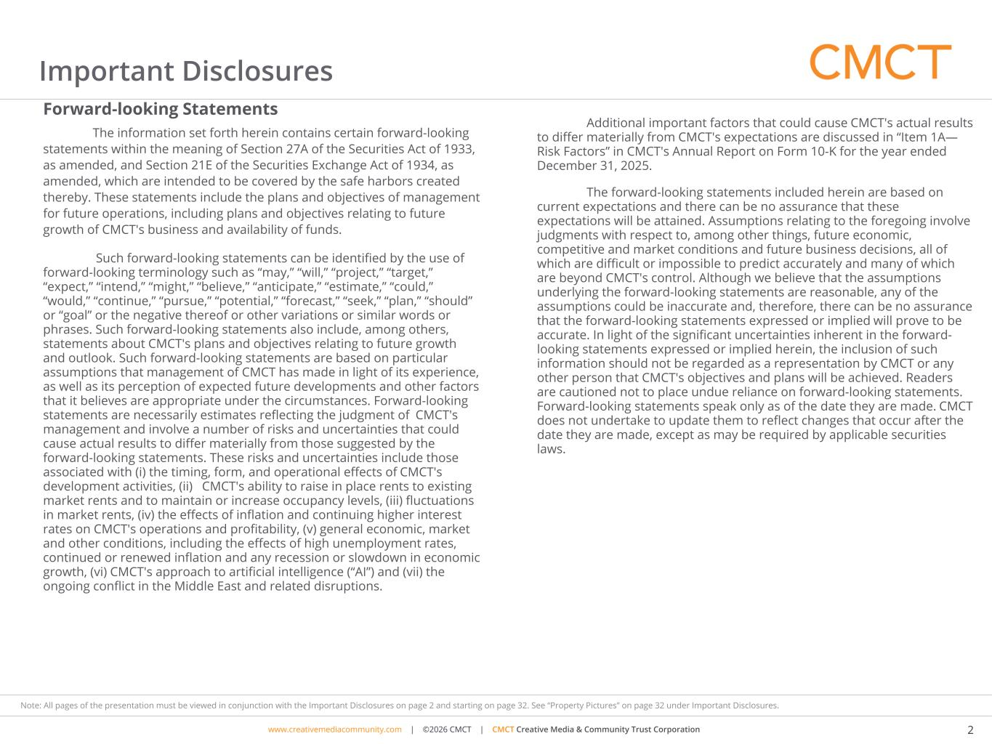
www.cimgroup.com | ©2018 CIM Group | TRADE SECRET / CONFIDENTIAL INFORMATIONwww.creativemediacommunity.com | ©2026 CMCT | CMCT Creative Media & Community Trust Corporation 2 Note: All pages of the presentation must be viewed in conjunction with the Important Disclosures on page 2 and starting on page 32. See “Property Pictures” on page 32 under Important Disclosures. Important Disclosures Forward-looking Statements The information set forth herein contains certain forward-looking statements within the meaning of Section 27A of the Securities Act of 1933, as amended, and Section 21E of the Securities Exchange Act of 1934, as amended, which are intended to be covered by the safe harbors created thereby. These statements include the plans and objectives of management for future operations, including plans and objectives relating to future growth of CMCT's business and availability of funds. Such forward-looking statements can be identified by the use of forward-looking terminology such as “may,” “will,” “project,” “target,” “expect,” “intend,” “might,” “believe,” “anticipate,” “estimate,” “could,” “would,” “continue,” “pursue,” “potential,” “forecast,” “seek,” “plan,” “should” or “goal” or the negative thereof or other variations or similar words or phrases. Such forward-looking statements also include, among others, statements about CMCT's plans and objectives relating to future growth and outlook. Such forward-looking statements are based on particular assumptions that management of CMCT has made in light of its experience, as well as its perception of expected future developments and other factors that it believes are appropriate under the circumstances. Forward-looking statements are necessarily estimates reflecting the judgment of CMCT's management and involve a number of risks and uncertainties that could cause actual results to differ materially from those suggested by the forward-looking statements. These risks and uncertainties include those associated with (i) the timing, form, and operational effects of CMCT's development activities, (ii) CMCT's ability to raise in place rents to existing market rents and to maintain or increase occupancy levels, (iii) fluctuations in market rents, (iv) the effects of inflation and continuing higher interest rates on CMCT's operations and profitability, (v) general economic, market and other conditions, including the effects of high unemployment rates, continued or renewed inflation and any recession or slowdown in economic growth, (vi) CMCT's approach to artificial intelligence (“AI”) and (vii) the ongoing conflict in the Middle East and related disruptions. Additional important factors that could cause CMCT's actual results to differ materially from CMCT's expectations are discussed in “Item 1A— Risk Factors” in CMCT's Annual Report on Form 10-K for the year ended December 31, 2025. The forward-looking statements included herein are based on current expectations and there can be no assurance that these expectations will be attained. Assumptions relating to the foregoing involve judgments with respect to, among other things, future economic, competitive and market conditions and future business decisions, all of which are difficult or impossible to predict accurately and many of which are beyond CMCT's control. Although we believe that the assumptions underlying the forward-looking statements are reasonable, any of the assumptions could be inaccurate and, therefore, there can be no assurance that the forward-looking statements expressed or implied will prove to be accurate. In light of the significant uncertainties inherent in the forward- looking statements expressed or implied herein, the inclusion of such information should not be regarded as a representation by CMCT or any other person that CMCT's objectives and plans will be achieved. Readers are cautioned not to place undue reliance on forward-looking statements. Forward-looking statements speak only as of the date they are made. CMCT does not undertake to update them to reflect changes that occur after the date they are made, except as may be required by applicable securities laws.

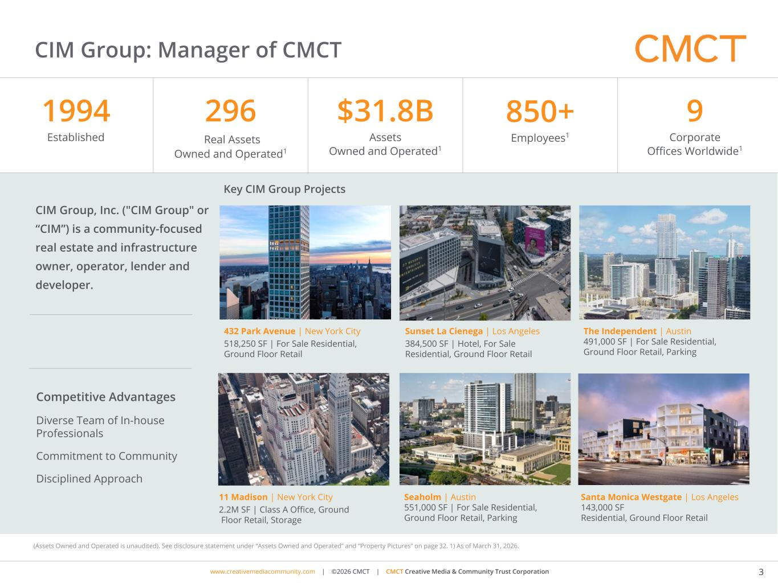
www.cimgroup.com | ©2018 CIM Group | TRADE SECRET / CONFIDENTIAL INFORMATIONwww.creativemediacommunity.com | ©2026 CMCT | CMCT Creative Media & Community Trust Corporation 3 Note: All pages of the presentation must be viewed in conjunction with the Important Disclosures on page 2 and starting on page 32. See “Property Pictures” on page 32 under Important Disclosures. (Assets Owned and Operated is unaudited). See disclosure statement under “Assets Owned and Operated” and “Property Pictures” on page 31. 1) As of September 30, 2025. 2) As of December 31, 2025. CIM Group: Manager of CMCT CIM Group, Inc. ("CIM Group" or “CIM”) is a community-focused real estate and infrastructure owner, operator, lender and developer. The Independent | Austin 491,000 SF | For Sale Residential, Ground Floor Retail, Parking Key CIM Group Projects Santa Monica Westgate | Los Angeles 143,000 SF Residential, Ground Floor Retail Sunset La Cienega | Los Angeles 384,500 SF | Hotel, For Sale Residential, Ground Floor Retail Seaholm | Austin 551,000 SF | For Sale Residential, Ground Floor Retail, Parking 432 Park Avenue | New York City 518,250 SF | For Sale Residential, Ground Floor Retail 11 Madison | New York City 2.2M SF | Class A Office, Ground Floor Retail, Storage 1994 Established 296 Real Assets Owned and Operated1 $31.8B Assets Owned and Operated1 850+ Employees1 9 Corporate Offices Worldwide1 Competitive Advantages Diverse Team of In-house Professionals Commitment to Community Disciplined Approach (Assets Owned and Operated is unaudited). See disclosure statement under “Assets Owned and Operated” and “Property Pictures” on page 32. 1) As of March 31, 20 6.

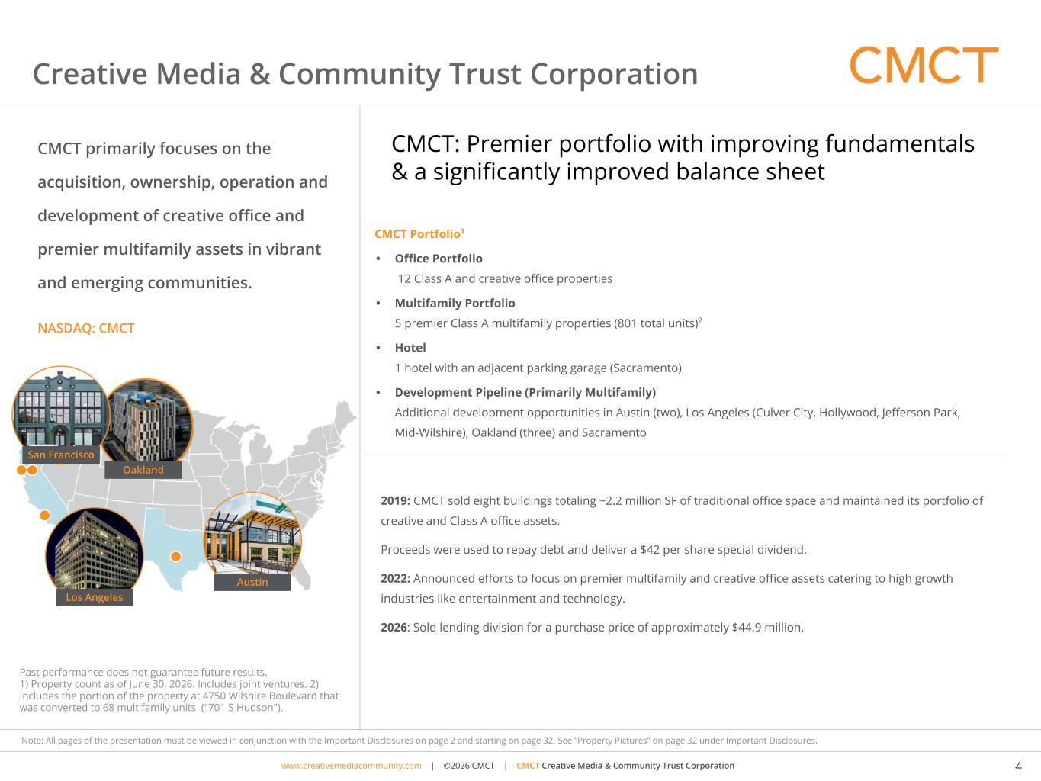
www.cimgroup.com | ©2018 CIM Group | TRADE SECRET / CONFIDENTIAL INFORMATIONwww.creativemediacommunity.com | ©2026 CMCT | CMCT Creative Media & Community Trust Corporation 4 Note: All pages of the presentation must be viewed in conjunction with the Important Disclosures on page 2 and starting on page 32. See “Property Pictures” on page 32 under Important Disclosures. Past performance does not guarantee future results. 1) Property count as of June 30, 2026. Includes joint ventures. 2) Includes the portion of the property at 4750 Wilshire Boulevard that was converted to 68 multifamily units ("701 S Hudson"). Creative Media & Community Trust Corporation CMCT primarily focuses on the acquisition, ownership, operation and development of creative office and premier multifamily assets in vibrant and emerging communities. NASDAQ: CMCT CMCT Portfolio1 • Office Portfolio 12 Class A and creative office properties • Multifamily Portfolio 5 premier Class A multifamily properties (801 total units)2 • Hotel 1 hotel with an adjacent parking garage (Sacramento) • Development Pipeline (Primarily Multifamily) Additional development opportunities in Austin (two), Los Angeles (Culver City, Hollywood, Jefferson Park, Mid-Wilshire), Oakland (three) and Sacramento 2019: CMCT sold eight buildings totaling ~2.2 million SF of traditional office space and maintained its portfolio of creative and Class A office assets. Proceeds were used to repay debt and deliver a $42 per share special dividend. 2022: Announced efforts to focus on premier multifamily and creative office assets catering to high growth industries like entertainment and technology. 2026: Sold lending division for a purchase price of approximately $44.9 million. Oakland Austin Los Angeles San Francisco CMCT: Premier portfolio with improving fundamentals & a significantly improved balance sheet

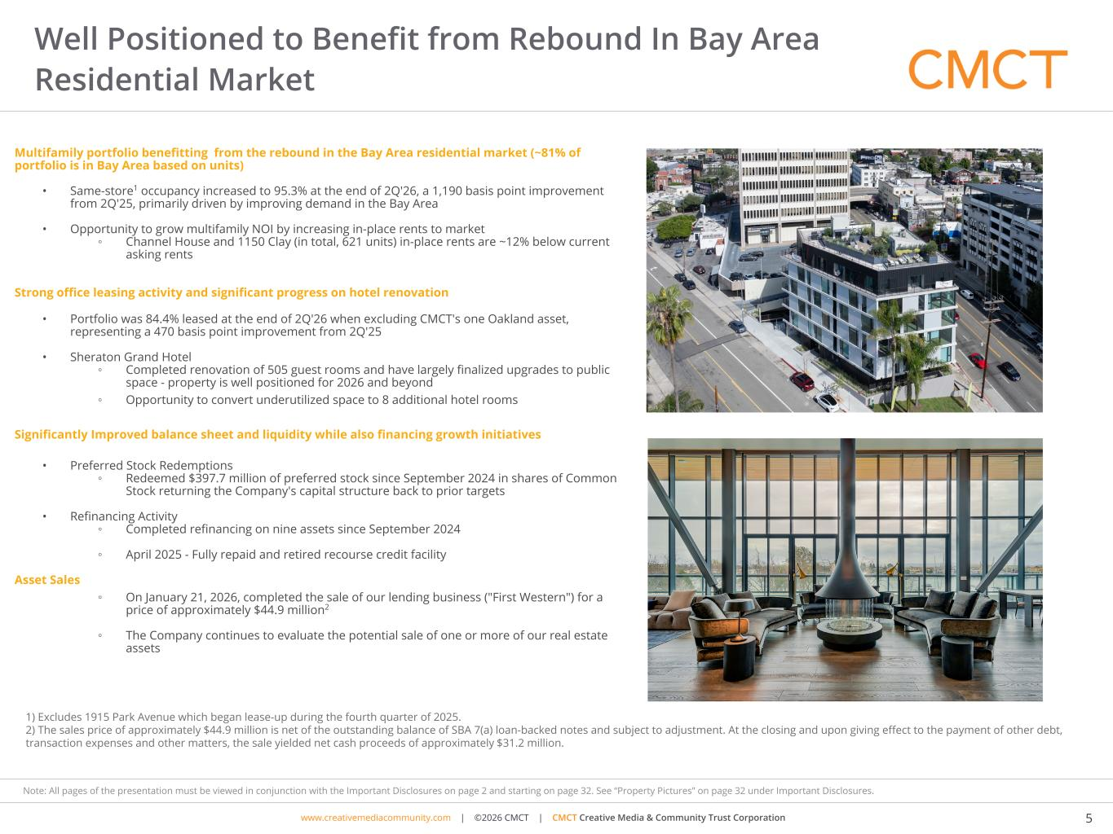
www.cimgroup.com | ©2018 CIM Group | TRADE SECRET / CONFIDENTIAL INFORMATIONwww.creativemediacommunity.com | ©2026 CMCT | CMCT Creative Media & Community Trust Corporation 5 Note: All pages of the presentation must be viewed in conjunction with the Important Disclosures on page 2 and starting on page 32. See “Property Pictures” on page 32 under Important Disclosures. Multifamily portfolio benefitting from the rebound in the Bay Area residential market (~81% of portfolio is in Bay Area based on units) • Same-store1 occupancy increased to 95.3% at the end of 2Q'26, a 1,190 basis point improvement from 2Q'25, primarily driven by improving demand in the Bay Area • Opportunity to grow multifamily NOI by increasing in-place rents to market ◦ Channel House and 1150 Clay (in total, 621 units) in-place rents are ~12% below current asking rents Strong office leasing activity and significant progress on hotel renovation • Portfolio was 84.4% leased at the end of 2Q'26 when excluding CMCT's one Oakland asset, representing a 470 basis point improvement from 2Q'25 • Sheraton Grand Hotel ◦ Completed renovation of 505 guest rooms and have largely finalized upgrades to public space - property is well positioned for 2026 and beyond ◦ Opportunity to convert underutilized space to 8 additional hotel rooms Significantly Improved balance sheet and liquidity while also financing growth initiatives • Preferred Stock Redemptions ◦ Redeemed $397.7 million of preferred stock since September 2024 in shares of Common Stock returning the Company's capital structure back to prior targets • Refinancing Activity ◦ Completed refinancing on nine assets since September 2024 ◦ April 2025 - Fully repaid and retired recourse credit facility Asset Sales ◦ On January 21, 2026, completed the sale of our lending business ("First Western") for a price of approximately $44.9 million2 ◦ The Company continues to evaluate the potential sale of one or more of our real estate assets Well Positioned to Benefit from Rebound In Bay Area Residential Market 1) Excludes 1915 Park Avenue which began lease-up during the fourth quarter of 2025. 2) The sales price of approximately $44.9 million is net of the outstanding balance of SBA 7(a) loan-backed notes and subject to adjustment. At the closing and upon giving effect to the payment of other debt, transaction expenses and other matters, the sale yielded net cash proceeds of approximately $31.2 million.

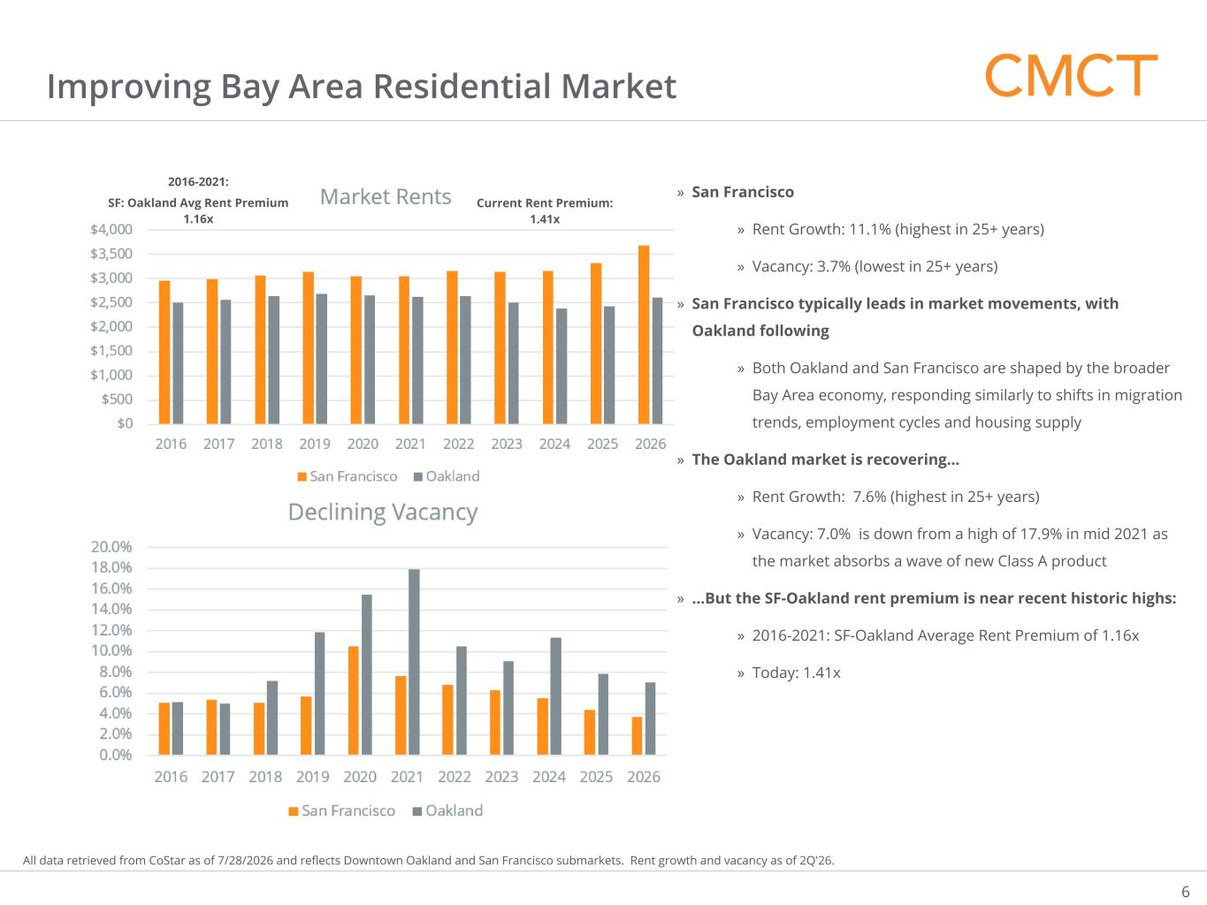
www.cimgroup.com | ©2018 CIM Group | TRADE SECRET / CONFIDENTIAL INFORMATION Improving Bay Area Residential Market 6 All data retrieved from CoStar as of 7/28/2026 and reflects Downtown Oakland and San Francisco submarkets. Rent growth and vacancy as of 2Q'26. » San Francisco » Rent Growth: 11.1% (highest in 25+ years) » Vacancy: 3.7% (lowest in 25+ years) » San Francisco typically leads in market movements, with Oakland following » Both Oakland and San Francisco are shaped by the broader Bay Area economy, responding similarly to shifts in migration trends, employment cycles and housing supply » The Oakland market is recovering… » Rent Growth: 7.6% (highest in 25+ years) » Vacancy: 7.0% is down from a high of 17.9% in mid 2021 as the market absorbs a wave of new Class A product » …But the SF-Oakland rent premium is near recent historic highs: » 2016-2021: SF-Oakland Average Rent Premium of 1.16x » Today: 1.41x 2016-2021: SF: Oakland Avg Rent Premium 1.16x Current Rent Premium: 1.41x

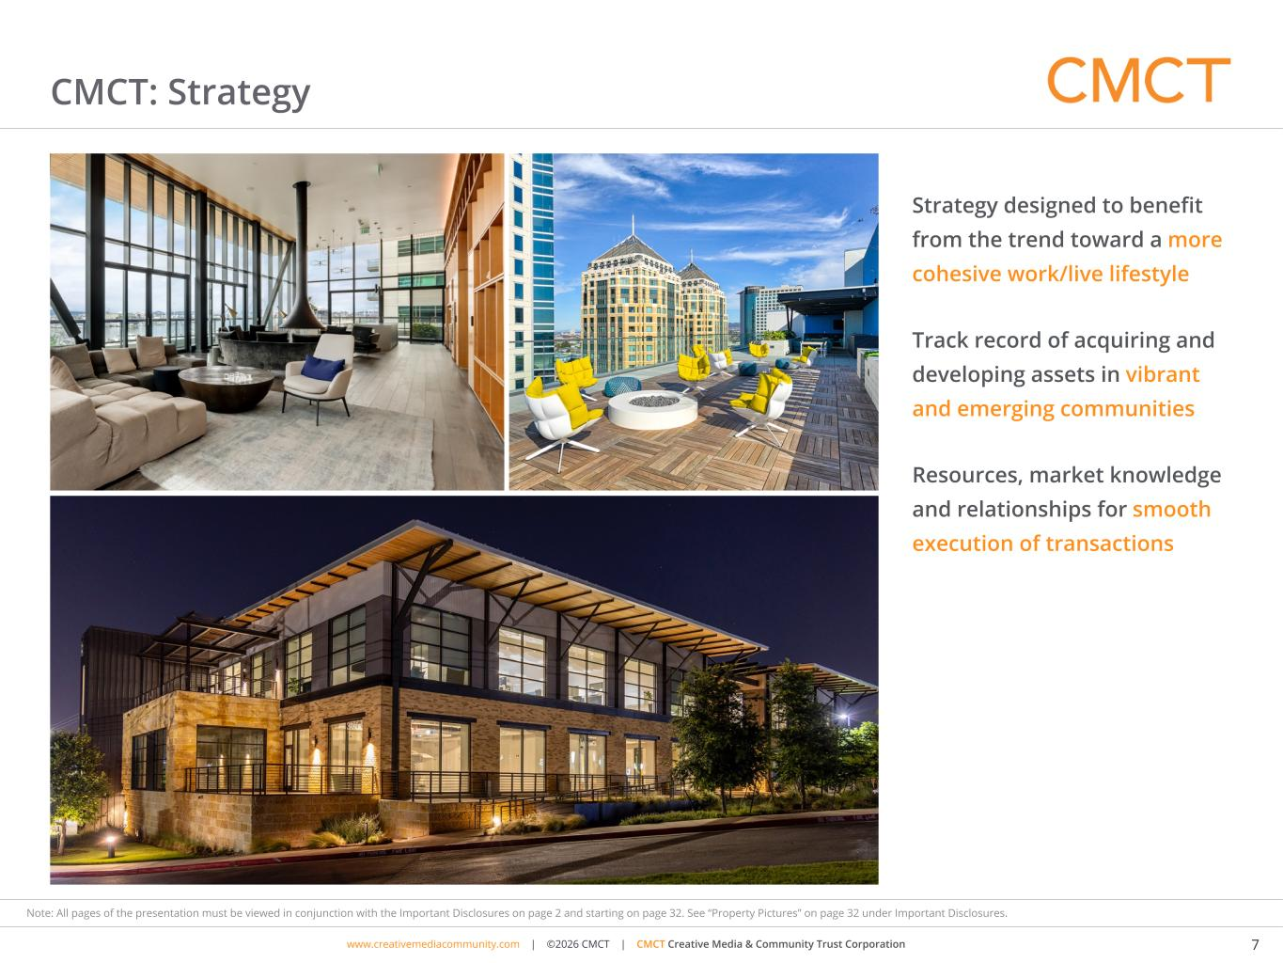
www.cimgroup.com | ©2018 CIM Group | TRADE SECRET / CONFIDENTIAL INFORMATIONwww.creativemediacommunity.com | ©2026 CMCT | CMCT Creative Media & Community Trust Corporation 7 Note: All pages of the presentation must be viewed in conjunction with the Important Disclosures on page 2 and starting on page 32. See “Property Pictures” on page 32 under Important Disclosures. Strategy designed to benefit from the trend toward a more cohesive work/live lifestyle Track record of acquiring and developing assets in vibrant and emerging communities Resources, market knowledge and relationships for smooth execution of transactions CMCT: Strategy

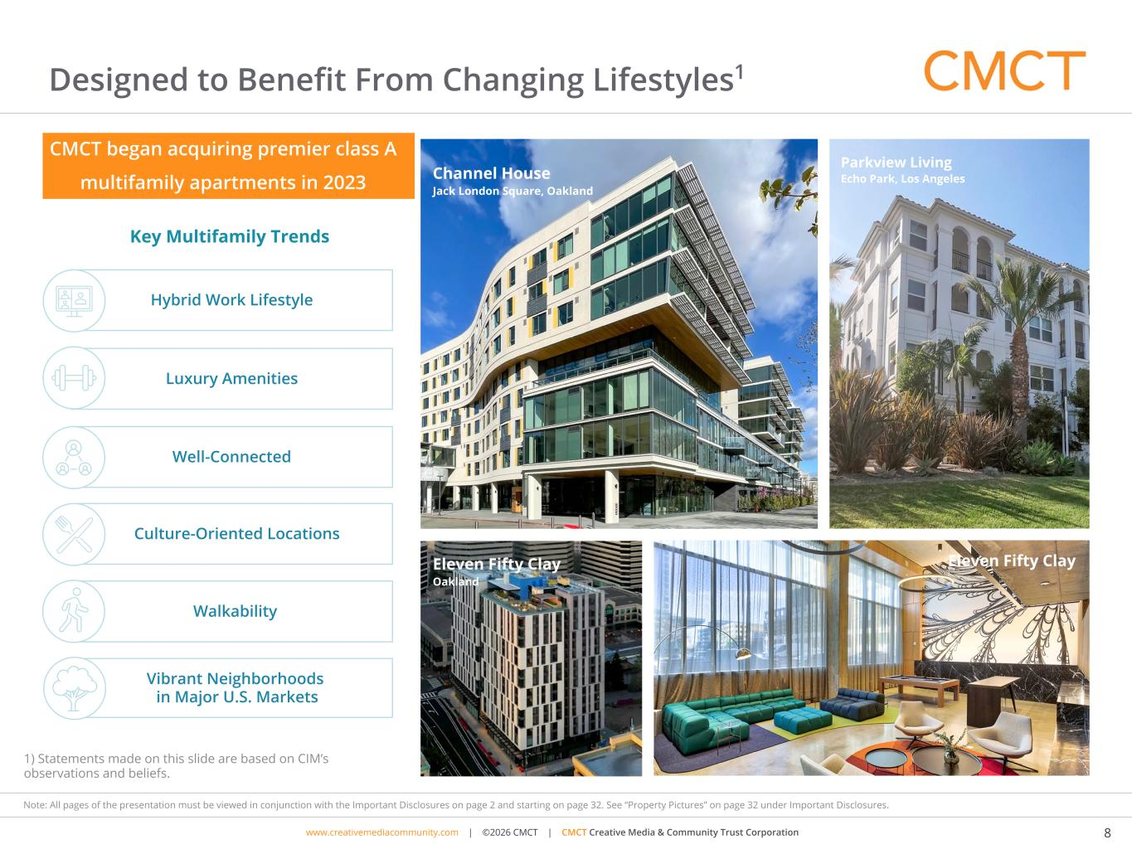
www.cimgroup.com | ©2018 CIM Group | TRADE SECRET / CONFIDENTIAL INFORMATIONwww.creativemediacommunity.com | ©2026 CMCT | CMCT Creative Media & Community Trust Corporation 8 Note: All pages of the presentation must be viewed in conjunction with the Important Disclosures on page 2 and starting on page 32. See “Property Pictures” on page 32 under Important Disclosures. Designed to Benefit From Changing Lifestyles1 Key Multifamily Trends Walkability Luxury Amenities Well-Connected Hybrid Work Lifestyle Culture-Oriented Locations Vibrant Neighborhoods in Major U.S. Markets 1) Statements made on this slide are based on CIM’s observations and beliefs. CMCT began acquiring premier class A multifamily apartments in 2023 Channel House Jack London Square, Oakland Parkview Living Echo Park, Los Angeles Eleven Fifty Clay Oakland Eleven Fifty Clay


www.cimgroup.com | ©2018 CIM Group | TRADE SECRET / CONFIDENTIAL INFORMATIONwww.creativemediacommunity.com | ©2026 CMCT | CMCT Creative Media & Community Trust Corporation 9 Note: All pages of the presentation must be viewed in conjunction with the Important Disclosures on page 2 and starting on page 32. See “Property Pictures” on page 32 under Important Disclosures. Designed to Benefit From Changing Lifestyles1 The pandemic accelerated the trend toward a more cohesive work/live lifestyle. 1) Statements made on this slide are based on CIM Group’s observations and beliefs. Key Office Trends » Growing demand for “creative office” » Desire for spaces that inspire employees » Emphasis on comfort, cool and “wow factor” » Battle to recruit and retain top talent What is “creative office”? Creative office space diverges from traditional office norms. It includes bright, open, and thoughtfully designed spaces that encourage creativity, flexibility and collaboration.

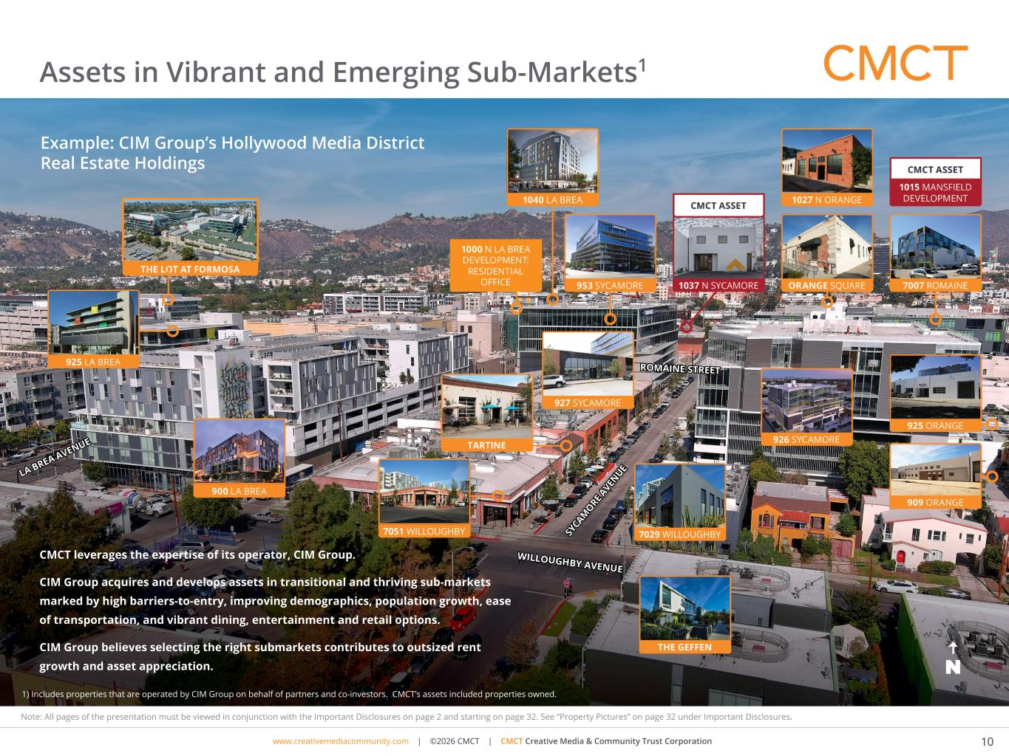
www.cimgroup.com | ©2018 CIM Group | TRADE SECRET / CONFIDENTIAL INFORMATIONwww.creativemediacommunity.com | ©2026 CMCT | CMCT Creative Media & Community Trust Corporation 10 Note: All pages of the presentation must be viewed in conjunction with the Important Disclosures on page 2 and starting on page 32. See “Property Pictures” on page 32 under Important Disclosures. Assets in Vibrant and Emerging Sub-Markets1 CMCT leverages the expertise of its operator, CIM Group. CIM Group acquires and develops assets in transitional and thriving sub-markets marked by high barriers-to-entry, improving demographics, population growth, ease of transportation, and vibrant dining, entertainment and retail options. CIM Group believes selecting the right submarkets contributes to outsized rent growth and asset appreciation. Example: CIM Group’s Hollywood Media District Real Estate Holdings 1) Includes properties that are operated by CIM Group on behalf of partners and co-investors. CMCT’s assets included properties owned.

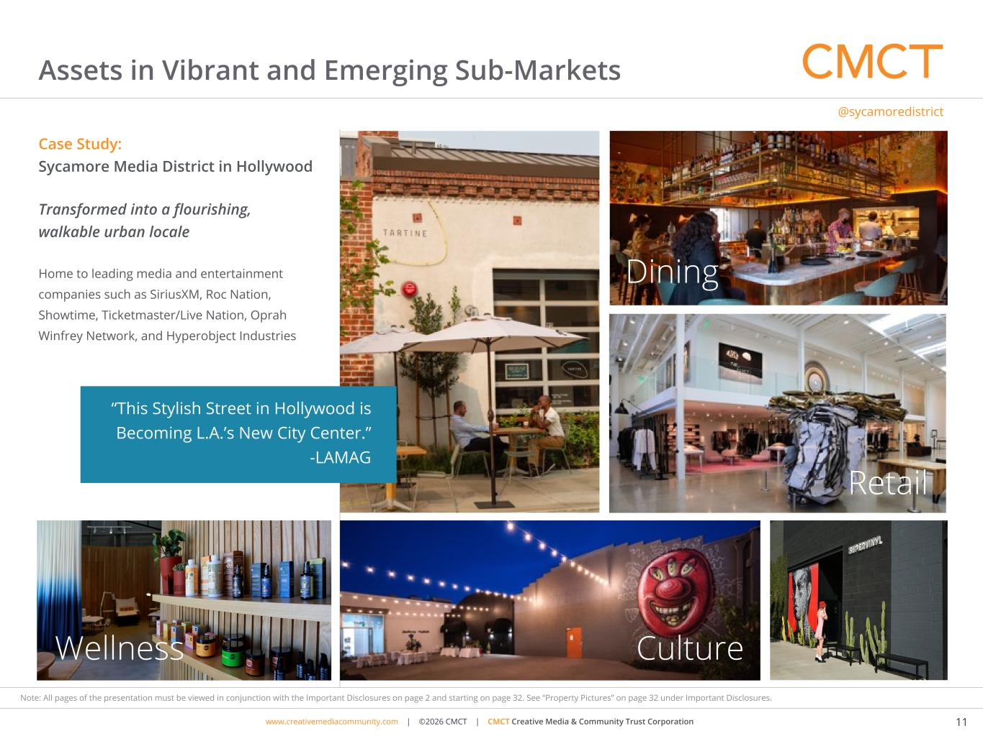
www.cimgroup.com | ©2018 CIM Group | TRADE SECRET / CONFIDENTIAL INFORMATIONwww.creativemediacommunity.com | ©2026 CMCT | CMCT Creative Media & Community Trust Corporation 11 Note: All pages of the presentation must be viewed in conjunction with the Important Disclosures on page 2 and starting on page 32. See “Property Pictures” on page 32 under Important Disclosures. Case Study: Sycamore Media District in Hollywood Transformed into a flourishing, walkable urban locale Home to leading media and entertainment companies such as SiriusXM, Roc Nation, Showtime, Ticketmaster/Live Nation, Oprah Winfrey Network, and Hyperobject Industries @sycamoredistrict Assets in Vibrant and Emerging Sub-Markets Retail “This Stylish Street in Hollywood is Becoming L.A.’s New City Center.” -LAMAG Dining CultureWellness


www.cimgroup.com | ©2018 CIM Group | TRADE SECRET / CONFIDENTIAL INFORMATIONwww.creativemediacommunity.com | ©2026 CMCT | CMCT Creative Media & Community Trust Corporation 12 Note: All pages of the presentation must be viewed in conjunction with the Important Disclosures on page 2 and starting on page 32. See “Property Pictures” on page 32 under Important Disclosures. Resources, Market-Knowledge and Relationships Core in-house capabilities include acquisition, credit analysis, development, financing, leasing, on-site property management and distribution CMCT Management Inside Board Members Avi Shemesh CIM Group Co-founder CMCT Board Member Responsible for CIM’s long-term relationships with strategic institutions and oversees teams essential to acquisitions, portfolio management and internal and external communication Richard Ressler CIM Group Co-founder CMCT Chairman of the Board Chair of CIM's Executive, Investment, Allocation and Real Assets Management Committees • Founder of Orchard Capital Corp., OFS Capital Management (a full service provider of leveraged finance solutions) and OCV Management (owner of technology companies) • Chairman of the Board of CIM Real Estate Finance Trust, Inc. • Previously worked at Drexel Burnham Lambert, Inc. and began his career as an attorney with Cravath, Swaine and Moore, LLP Shaul Kuba CMCT Chief Investment Officer and CMCT Board Member CIM Group Co-founder Head of CIM’s Development Team and actively involved in the successful development, redevelopment and repositioning of CIM’s real estate assets around the U.S. David Thompson CMCT CEO CIM Group CFO and Principal 15 years of previous experience with Hilton Hotels Corporation, most recently as Senior Vice President and Controller Brandon Hill CMCT CFO and Treasurer Has served as 1st Vice President - Fund Accounting & Reporting for CIM Group, L.P. since March 2022. Prior to his role as 1st Vice President - Fund Accounting & Reporting, Mr. Hill served as Vice President - Financial Reporting for CIM Group, L.P. from 2018 to 2022

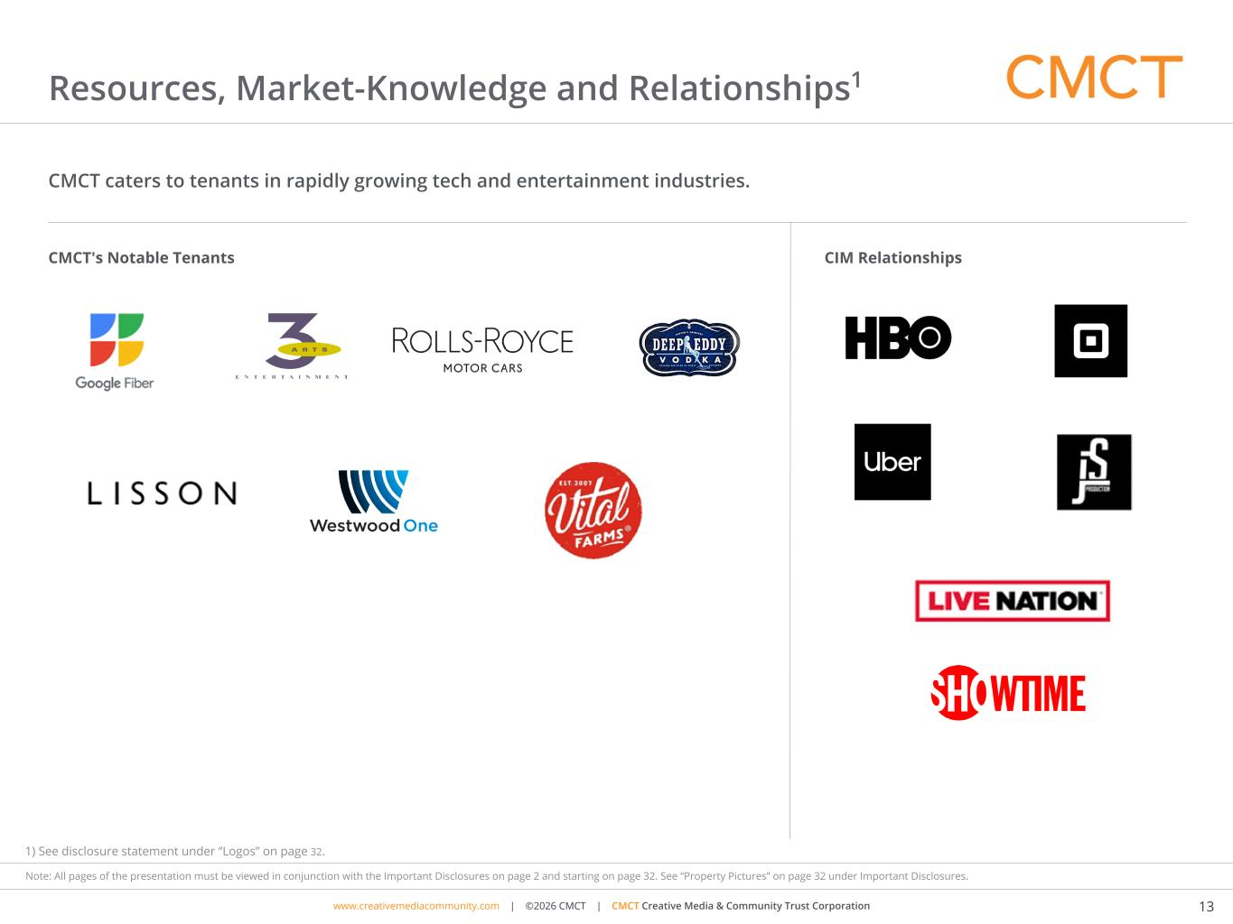
www.cimgroup.com | ©2018 CIM Group | TRADE SECRET / CONFIDENTIAL INFORMATIONwww.creativemediacommunity.com | ©2026 CMCT | CMCT Creative Media & Community Trust Corporation 13 Note: All pages of the presentation must be viewed in conjunction with the Important Disclosures on page 2 and starting on page 32. See “Property Pictures” on page 32 under Important Disclosures. Resources, Market-Knowledge and Relationships1 CMCT caters to tenants in rapidly growing tech and entertainment industries. CMCT's Notable Tenants CIM Relationships 1) See disclosure statement under “Logos” on page 32.

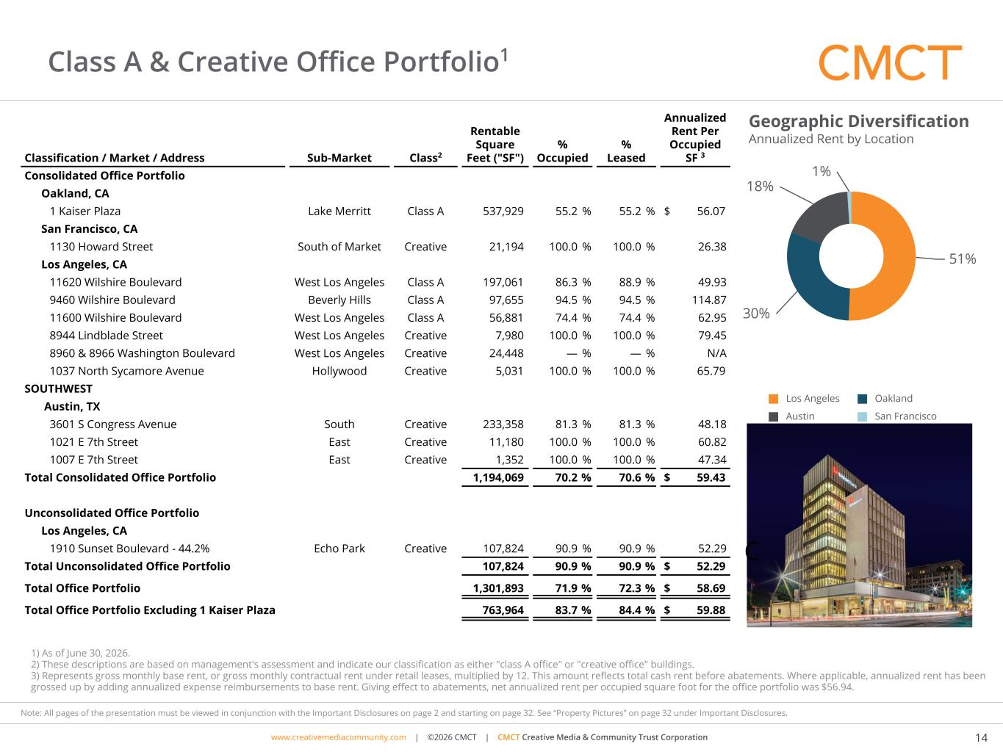
www.cimgroup.com | ©2018 CIM Group | TRADE SECRET / CONFIDENTIAL INFORMATIONwww.creativemediacommunity.com | ©2026 CMCT | CMCT Creative Media & Community Trust Corporation 14 Note: All pages of the presentation must be viewed in conjunction with the Important Disclosures on page 2 and starting on page 32. See “Property Pictures” on page 32 under Important Disclosures. Class A & Creative Office Portfolio1 Classification / Market / Address Sub-Market Class2 Rentable Square Feet ("SF") % Occupied % Leased Annualized Rent Per Occupied SF 3 Consolidated Office Portfolio Oakland, CA 1 Kaiser Plaza Lake Merritt Class A 537,929 55.2 % 55.2 % $ 56.07 San Francisco, CA 1130 Howard Street South of Market Creative 21,194 100.0 % 100.0 % 26.38 Los Angeles, CA 11620 Wilshire Boulevard West Los Angeles Class A 197,061 86.3 % 88.9 % 49.93 9460 Wilshire Boulevard Beverly Hills Class A 97,655 94.5 % 94.5 % 114.87 11600 Wilshire Boulevard West Los Angeles Class A 56,881 74.4 % 74.4 % 62.95 8944 Lindblade Street West Los Angeles Creative 7,980 100.0 % 100.0 % 79.45 8960 & 8966 Washington Boulevard West Los Angeles Creative 24,448 — % — % N/A 1037 North Sycamore Avenue Hollywood Creative 5,031 100.0 % 100.0 % 65.79 SOUTHWEST Austin, TX 3601 S Congress Avenue South Creative 233,358 81.3 % 81.3 % 48.18 1021 E 7th Street East Creative 11,180 100.0 % 100.0 % 60.82 1007 E 7th Street East Creative 1,352 100.0 % 100.0 % 47.34 Total Consolidated Office Portfolio 1,194,069 70.2 % 70.6 % $ 59.43 Unconsolidated Office Portfolio Los Angeles, CA 1910 Sunset Boulevard - 44.2% Echo Park Creative 107,824 90.9 % 90.9 % 52.29 Total Unconsolidated Office Portfolio 107,824 90.9 % 90.9 % $ 52.29 Total Office Portfolio 1,301,893 71.9 % 72.3 % $ 58.69 Total Office Portfolio Excluding 1 Kaiser Plaza 763,964 83.7 % 84.4 % $ 59.88 51% 30% 18% 1% Los Angeles Oakland Austin San Francisco 1) As of June 30, 2026. 2) These descriptions are based on management's assessment and indicate our classification as either "class A office" or "creative office" buildings. 3) Represents gross monthly base rent, or gross monthly contractual rent under retail leases, multiplied by 12. This amount reflects total cash rent before abatements. Where applicable, annualized rent has been grossed up by adding annualized expense reimbursements to base rent. Giving effect to abatements, net annualized rent per occupied square foot for the office portfolio was $56.94. Geographic Diversification Annualized Rent by Location C

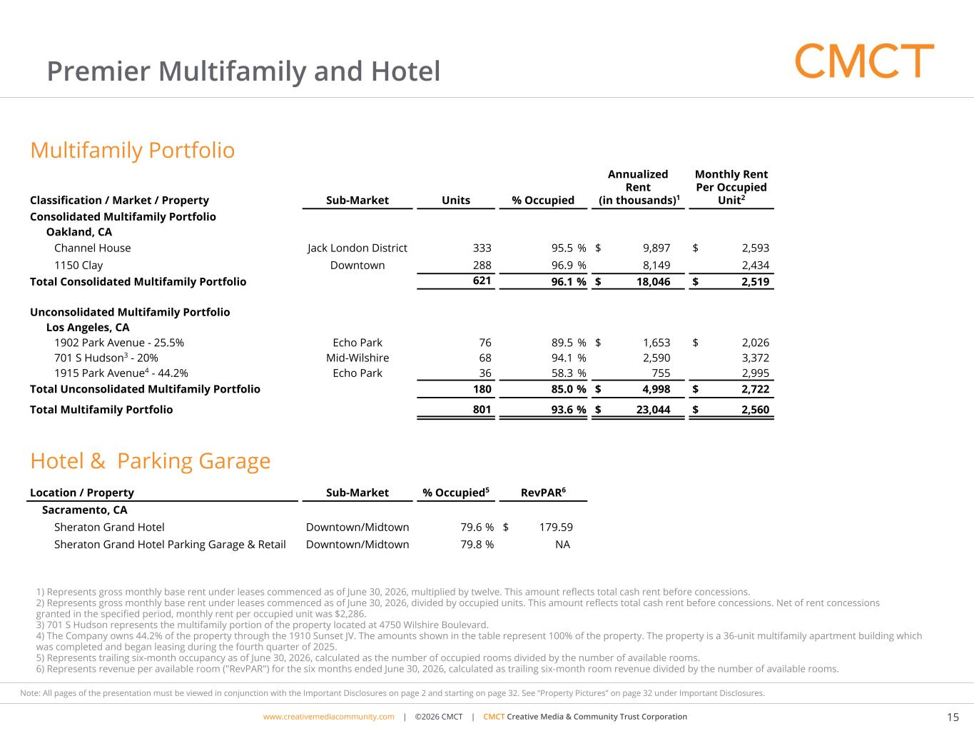
www.cimgroup.com | ©2018 CIM Group | TRADE SECRET / CONFIDENTIAL INFORMATIONwww.creativemediacommunity.com | ©2026 CMCT | CMCT Creative Media & Community Trust Corporation 15 Note: All pages of the presentation must be viewed in conjunction with the Important Disclosures on page 2 and starting on page 32. See “Property Pictures” on page 32 under Important Disclosures. 1) Represents gross monthly base rent under leases commenced as of June 30, 2026, multiplied by twelve. This amount reflects total cash rent before concessions. 2) Represents gross monthly base rent under leases commenced as of June 30, 2026, divided by occupied units. This amount reflects total cash rent before concessions. Net of rent concessions granted in the specified period, monthly rent per occupied unit was $2,286. 3) 701 S Hudson represents the multifamily portion of the property located at 4750 Wilshire Boulevard. 4) The Company owns 44.2% of the property through the 1910 Sunset JV. The amounts shown in the table represent 100% of the property. The property is a 36-unit multifamily apartment building which was completed and began leasing during the fourth quarter of 2025. 5) Represents trailing six-month occupancy as of June 30, 2026, calculated as the number of occupied rooms divided by the number of available rooms. 6) Represents revenue per available room ("RevPAR") for the six months ended June 30, 2026, calculated as trailing six-month room revenue divided by the number of available rooms. Premier Multifamily and Hotel Multifamily Portfolio Classification / Market / Property Sub-Market Units % Occupied Annualized Rent (in thousands)1 Monthly Rent Per Occupied Unit2 Consolidated Multifamily Portfolio Oakland, CA Channel House Jack London District 333 95.5 % $ 9,897 $ 2,593 1150 Clay Downtown 288 96.9 % 8,149 2,434 Total Consolidated Multifamily Portfolio 621 96.1 % $ 18,046 $ 2,519 Unconsolidated Multifamily Portfolio Los Angeles, CA 1902 Park Avenue - 25.5% Echo Park 76 89.5 % $ 1,653 $ 2,026 701 S Hudson3 - 20% Mid-Wilshire 68 94.1 % 2,590 3,372 1915 Park Avenue4 - 44.2% Echo Park 36 58.3 % 755 2,995 Total Unconsolidated Multifamily Portfolio 180 85.0 % $ 4,998 $ 2,722 Total Multifamily Portfolio 801 93.6 % $ 23,044 $ 2,560 Hotel & Parking Garage Location / Property Sub-Market % Occupied5 RevPAR6 Sacramento, CA Sheraton Grand Hotel Downtown/Midtown 79.6 % $ 179.59 Sheraton Grand Hotel Parking Garage & Retail Downtown/Midtown 79.8 % NA

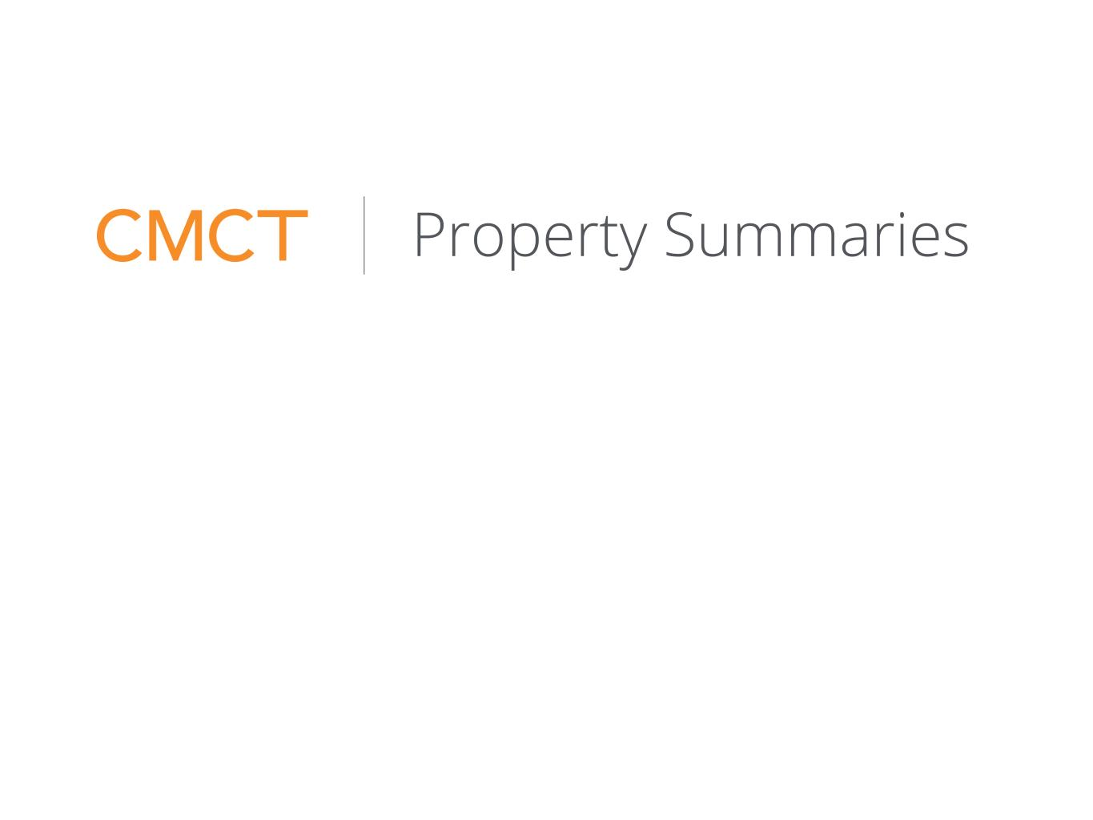
www.cimgroup.com | ©2018 CIM Group | TRADE SECRET / CONFIDENTIAL INFORMATION Property Summaries

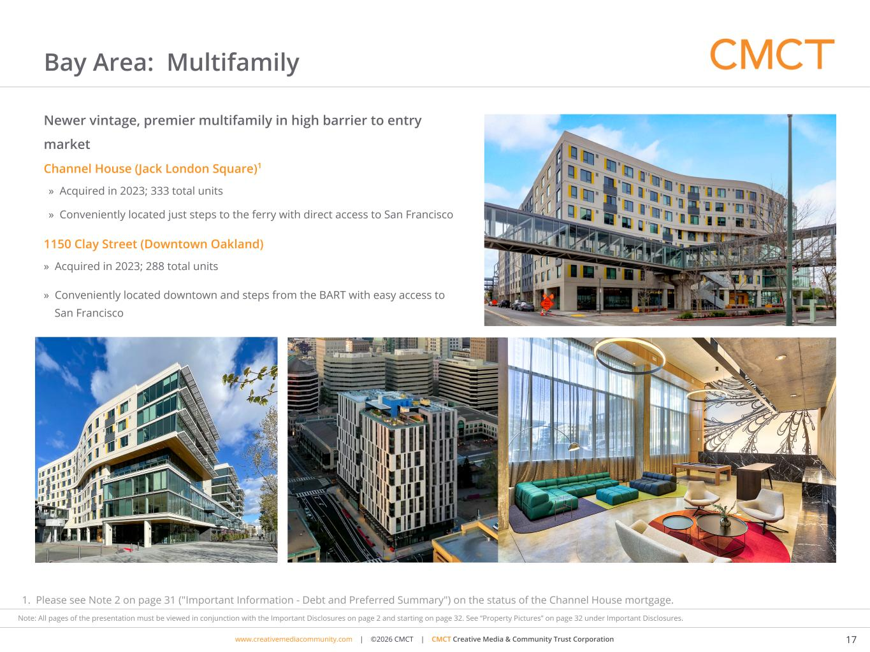
www.cimgroup.com | ©2018 CIM Group | TRADE SECRET / CONFIDENTIAL INFORMATIONwww.creativemediacommunity.com | ©2026 CMCT | CMCT Creative Media & Community Trust Corporation 17 Note: All pages of the presentation must be viewed in conjunction with the Important Disclosures on page 2 and starting on page 32. See “Property Pictures” on page 32 under Important Disclosures. 1. Please see Note 2 on page 31 ("Important Information - Debt and Preferred Summary") on the status of the Channel House mortgage. Bay Area: Multifamily Channel House (Jack London Square)1 » Acquired in 2023; 333 total units » Conveniently located just steps to the ferry with direct access to San Francisco 1150 Clay Street (Downtown Oakland) » Acquired in 2023; 288 total units » Conveniently located downtown and steps from the BART with easy access to San Francisco Newer vintage, premier multifamily in high barrier to entry market

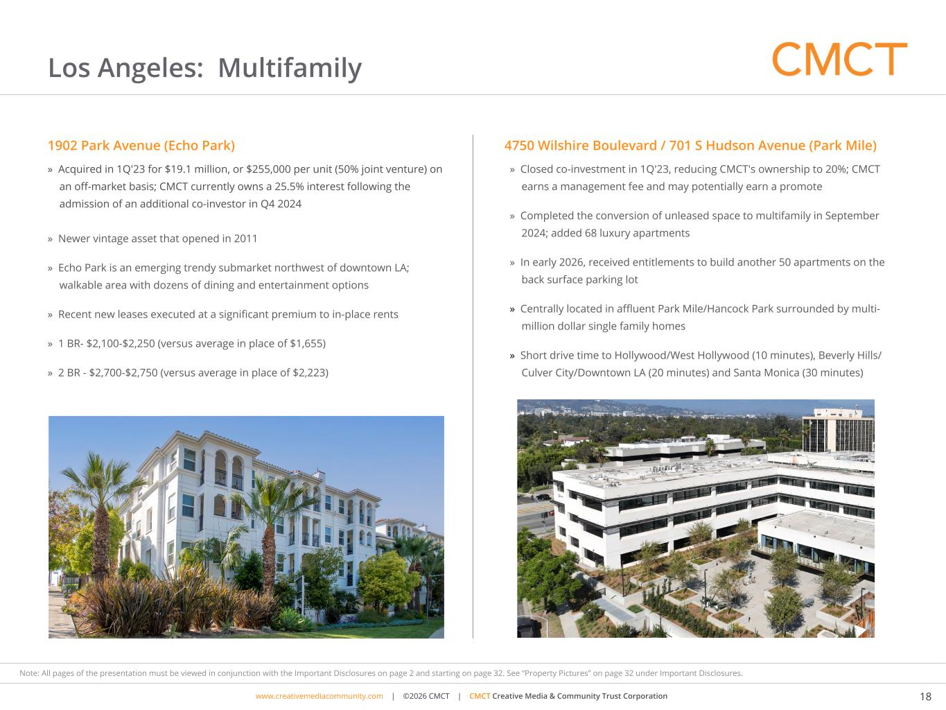
www.cimgroup.com | ©2018 CIM Group | TRADE SECRET / CONFIDENTIAL INFORMATIONwww.creativemediacommunity.com | ©2026 CMCT | CMCT Creative Media & Community Trust Corporation 18 Note: All pages of the presentation must be viewed in conjunction with the Important Disclosures on page 2 and starting on page 32. See “Property Pictures” on page 32 under Important Disclosures. Los Angeles: Multifamily 4750 Wilshire Boulevard / 701 S Hudson Avenue (Park Mile) » Closed co-investment in 1Q'23, reducing CMCT's ownership to 20%; CMCT earns a management fee and may potentially earn a promote » Completed the conversion of unleased space to multifamily in September 2024; added 68 luxury apartments » In early 2026, received entitlements to build another 50 apartments on the back surface parking lot » Centrally located in affluent Park Mile/Hancock Park surrounded by multi- million dollar single family homes » Short drive time to Hollywood/West Hollywood (10 minutes), Beverly Hills/ Culver City/Downtown LA (20 minutes) and Santa Monica (30 minutes) 1902 Park Avenue (Echo Park) » Acquired in 1Q'23 for $19.1 million, or $255,000 per unit (50% joint venture) on an off-market basis; CMCT currently owns a 25.5% interest following the admission of an additional co-investor in Q4 2024 » Newer vintage asset that opened in 2011 » Echo Park is an emerging trendy submarket northwest of downtown LA; walkable area with dozens of dining and entertainment options » Recent new leases executed at a significant premium to in-place rents » 1 BR- $2,100-$2,250 (versus average in place of $1,655) » 2 BR - $2,700-$2,750 (versus average in place of $2,223)

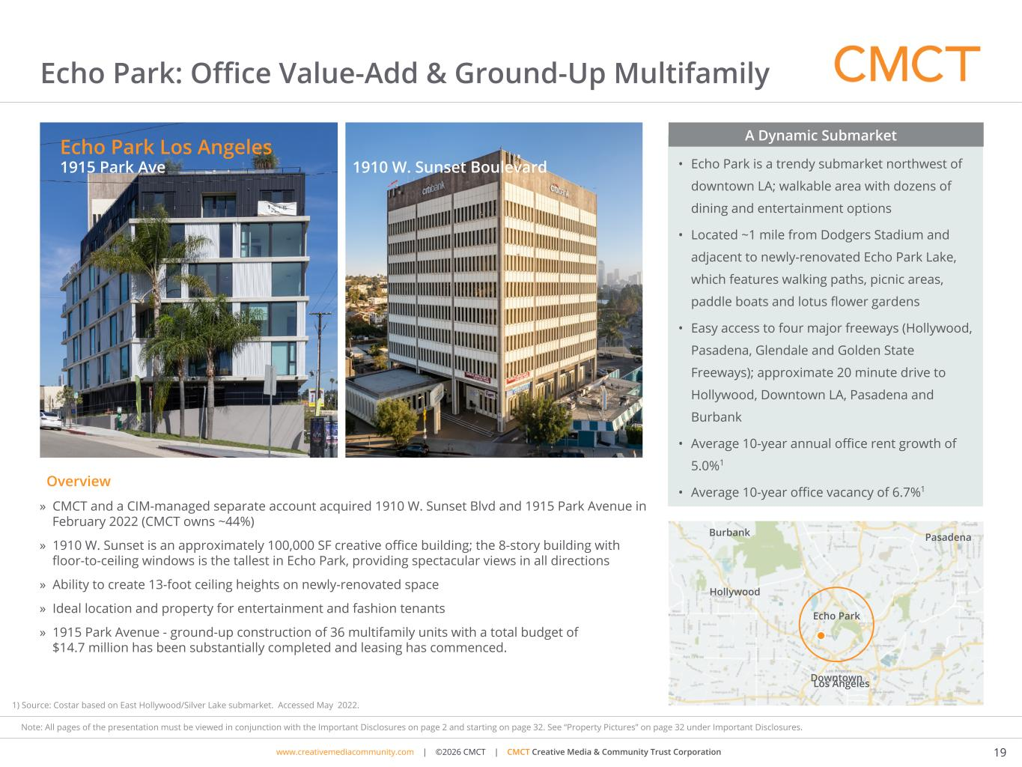
www.cimgroup.com | ©2018 CIM Group | TRADE SECRET / CONFIDENTIAL INFORMATIONwww.creativemediacommunity.com | ©2026 CMCT | CMCT Creative Media & Community Trust Corporation 19 Note: All pages of the presentation must be viewed in conjunction with the Important Disclosures on page 2 and starting on page 32. See “Property Pictures” on page 32 under Important Disclosures. Echo Park: Office Value-Add & Ground-Up Multifamily » CMCT and a CIM-managed separate account acquired 1910 W. Sunset Blvd and 1915 Park Avenue in February 2022 (CMCT owns ~44%) » 1910 W. Sunset is an approximately 100,000 SF creative office building; the 8-story building with floor-to-ceiling windows is the tallest in Echo Park, providing spectacular views in all directions » Ability to create 13-foot ceiling heights on newly-renovated space » Ideal location and property for entertainment and fashion tenants » 1915 Park Avenue - ground-up construction of 36 multifamily units with a total budget of $14.7 million has been substantially completed and leasing has commenced. • Echo Park is a trendy submarket northwest of downtown LA; walkable area with dozens of dining and entertainment options • Located ~1 mile from Dodgers Stadium and adjacent to newly-renovated Echo Park Lake, which features walking paths, picnic areas, paddle boats and lotus flower gardens • Easy access to four major freeways (Hollywood, Pasadena, Glendale and Golden State Freeways); approximate 20 minute drive to Hollywood, Downtown LA, Pasadena and Burbank • Average 10-year annual office rent growth of 5.0%1 • Average 10-year office vacancy of 6.7%1 A Dynamic Submarket Echo Park Los Angeles 1915 Park Ave 1910 W. Sunset Boulevard Overview Echo Park Downtown Los Angeles Hollywood PasadenaBurbank 1) Source: Costar based on East Hollywood/Silver Lake submarket. Accessed May 2022.

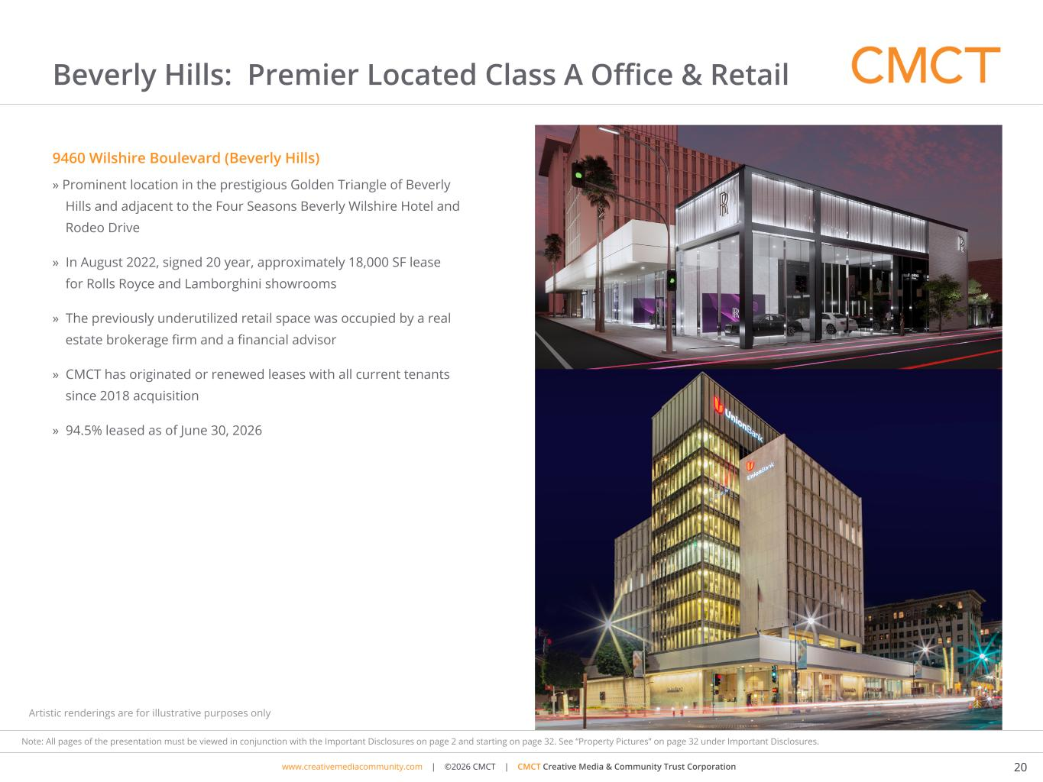
www.cimgroup.com | ©2018 CIM Group | TRADE SECRET / CONFIDENTIAL INFORMATIONwww.creativemediacommunity.com | ©2026 CMCT | CMCT Creative Media & Community Trust Corporation 20 Note: All pages of the presentation must be viewed in conjunction with the Important Disclosures on page 2 and starting on page 32. See “Property Pictures” on page 32 under Important Disclosures. Beverly Hills: Premier Located Class A Office & Retail 9460 Wilshire Boulevard (Beverly Hills) » Prominent location in the prestigious Golden Triangle of Beverly Hills and adjacent to the Four Seasons Beverly Wilshire Hotel and Rodeo Drive » In August 2022, signed 20 year, approximately 18,000 SF lease for Rolls Royce and Lamborghini showrooms » The previously underutilized retail space was occupied by a real estate brokerage firm and a financial advisor » CMCT has originated or renewed leases with all current tenants since 2018 acquisition » 94.5% leased as of June 30, 2026 Artistic renderings are for illustrative purposes only

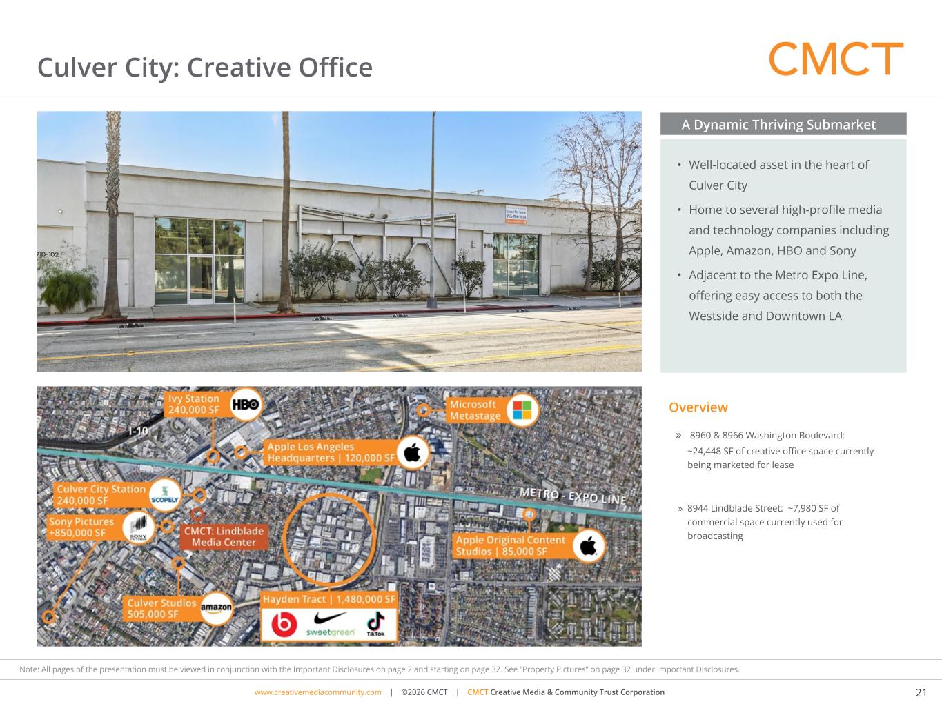
www.cimgroup.com | ©2018 CIM Group | TRADE SECRET / CONFIDENTIAL INFORMATIONwww.creativemediacommunity.com | ©2026 CMCT | CMCT Creative Media & Community Trust Corporation 21 Note: All pages of the presentation must be viewed in conjunction with the Important Disclosures on page 2 and starting on page 32. See “Property Pictures” on page 32 under Important Disclosures. Culver City: Creative Office » 8960 & 8966 Washington Boulevard: ~24,448 SF of creative office space currently being marketed for lease » 8944 Lindblade Street: ~7,980 SF of commercial space currently used for broadcasting Culver City Los Angeles Overview • Well-located asset in the heart of Culver City • Home to several high-profile media and technology companies including Apple, Amazon, HBO and Sony • Adjacent to the Metro Expo Line, offering easy access to both the Westside and Downtown LA A Dynamic Thriving Submarket Artistic renderings are for illustrative purposes only

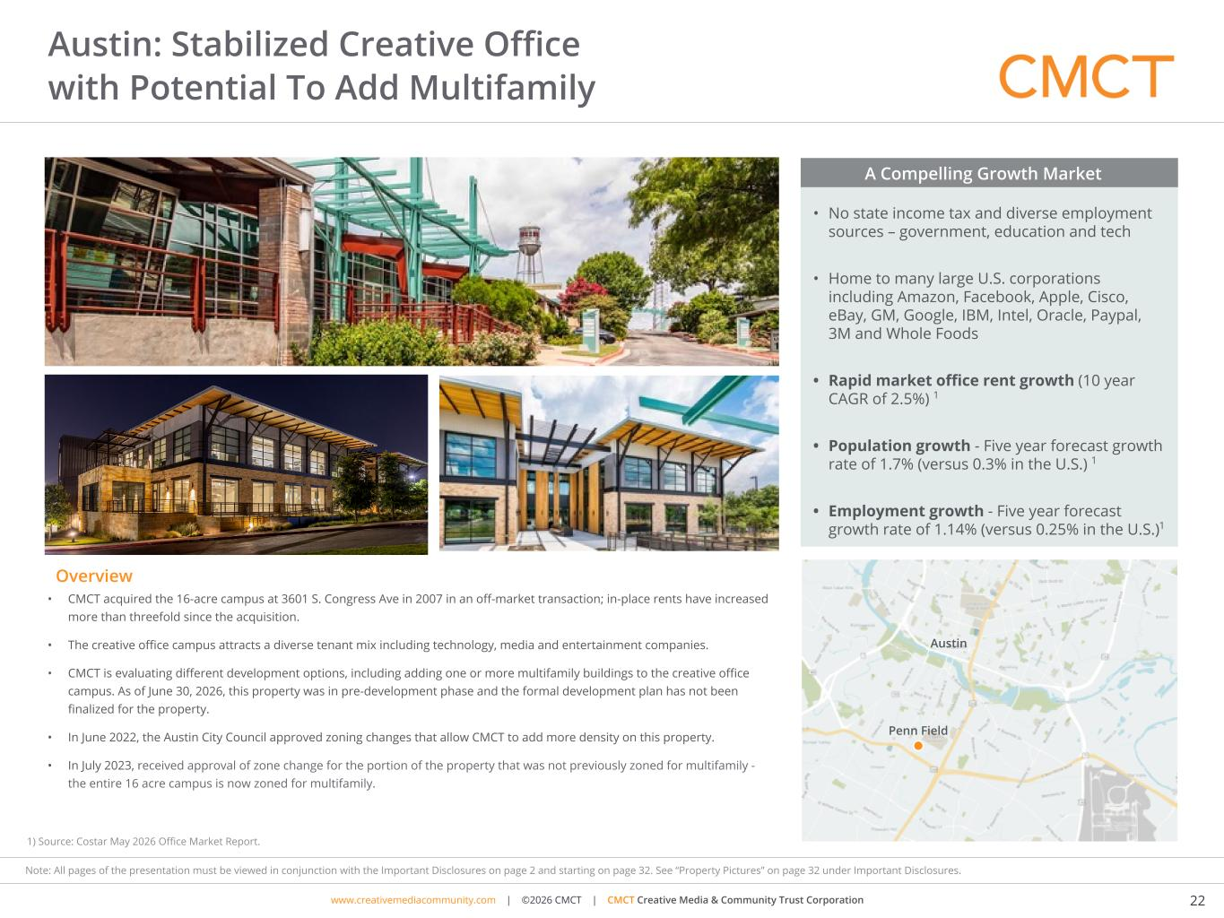
www.cimgroup.com | ©2018 CIM Group | TRADE SECRET / CONFIDENTIAL INFORMATIONwww.creativemediacommunity.com | ©2026 CMCT | CMCT Creative Media & Community Trust Corporation 22 Note: All pages of the presentation must be viewed in conjunction with the Important Disclosures on page 2 and starting on page 32. See “Property Pictures” on page 32 under Important Disclosures. Austin: Stabilized Creative Office with Potential To Add Multifamily • CMCT acquired the 16-acre campus at 3601 S. Congress Ave in 2007 in an off-market transaction; in-place rents have increased more than threefold since the acquisition. • The creative office campus attracts a diverse tenant mix including technology, media and entertainment companies. • CMCT is evaluating different development options, including adding one or more multifamily buildings to the creative office campus. As of June 30, 2026, this property was in pre-development phase and the formal development plan has not been finalized for the property. • In June 2022, the Austin City Council approved zoning changes that allow CMCT to add more density on this property. • In July 2023, received approval of zone change for the portion of the property that was not previously zoned for multifamily - the entire 16 acre campus is now zoned for multifamily. • No state income tax and diverse employment sources – government, education and tech • Home to many large U.S. corporations including Amazon, Facebook, Apple, Cisco, eBay, GM, Google, IBM, Intel, Oracle, Paypal, 3M and Whole Foods • Rapid market office rent growth (10 year CAGR of 2.5%) 1 • Population growth - Five year forecast growth rate of 1.7% (versus 0.3% in the U.S.) 1 • Employment growth - Five year forecast growth rate of 1.14% (versus 0.25% in the U.S.)1 A Compelling Growth Market Austin Overview Penn Field Penn Field Austin 1) Source: Costar May 2026 Office Market Report.

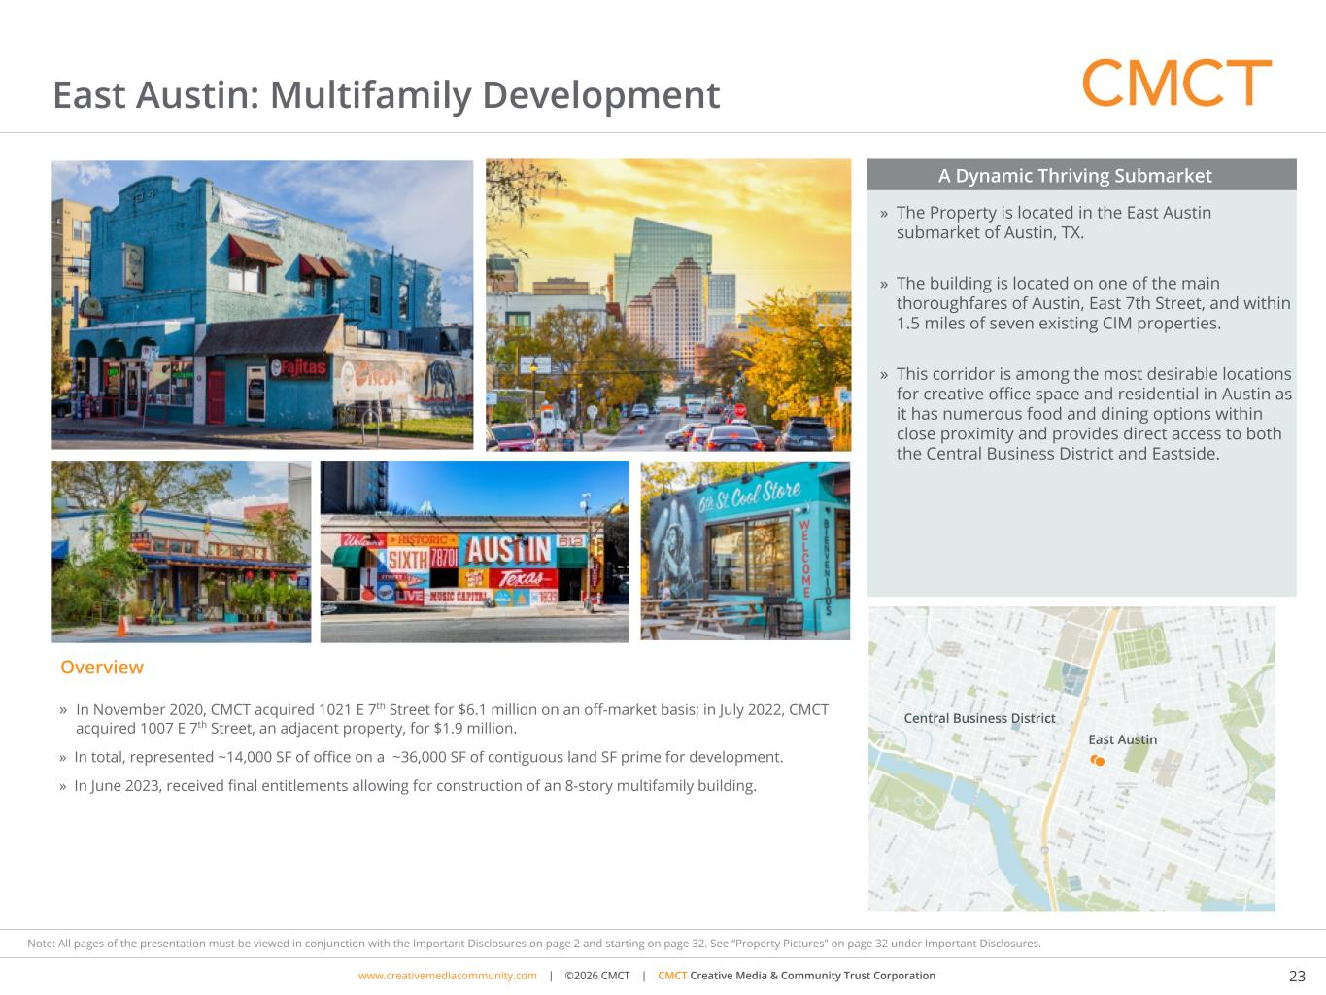
www.cimgroup.com | ©2018 CIM Group | TRADE SECRET / CONFIDENTIAL INFORMATIONwww.creativemediacommunity.com | ©2026 CMCT | CMCT Creative Media & Community Trust Corporation 23 Note: All pages of the presentation must be viewed in conjunction with the Important Disclosures on page 2 and starting on page 32. See “Property Pictures” on page 32 under Important Disclosures. East Austin: Multifamily Development » The Property is located in the East Austin submarket of Austin, TX. » The building is located on one of the main thoroughfares of Austin, East 7th Street, and within 1.5 miles of seven existing CIM properties. » This corridor is among the most desirable locations for creative office space and residential in Austin as it has numerous food and dining options within close proximity and provides direct access to both the Central Business District and Eastside. A Dynamic Thriving Submarket Overview Central Business District East Austin East Austin, Texas » In November 2020, CMCT acquired 1021 E 7th Street for $6.1 million on an off-market basis; in July 2022, CMCT acquired 1007 E 7th Street, an adjacent property, for $1.9 million. » In total, represented ~14,000 SF of office on a ~36,000 SF of contiguous land SF prime for development. » In June 2023, received final entitlements allowing for construction of an 8-story multifamily building.

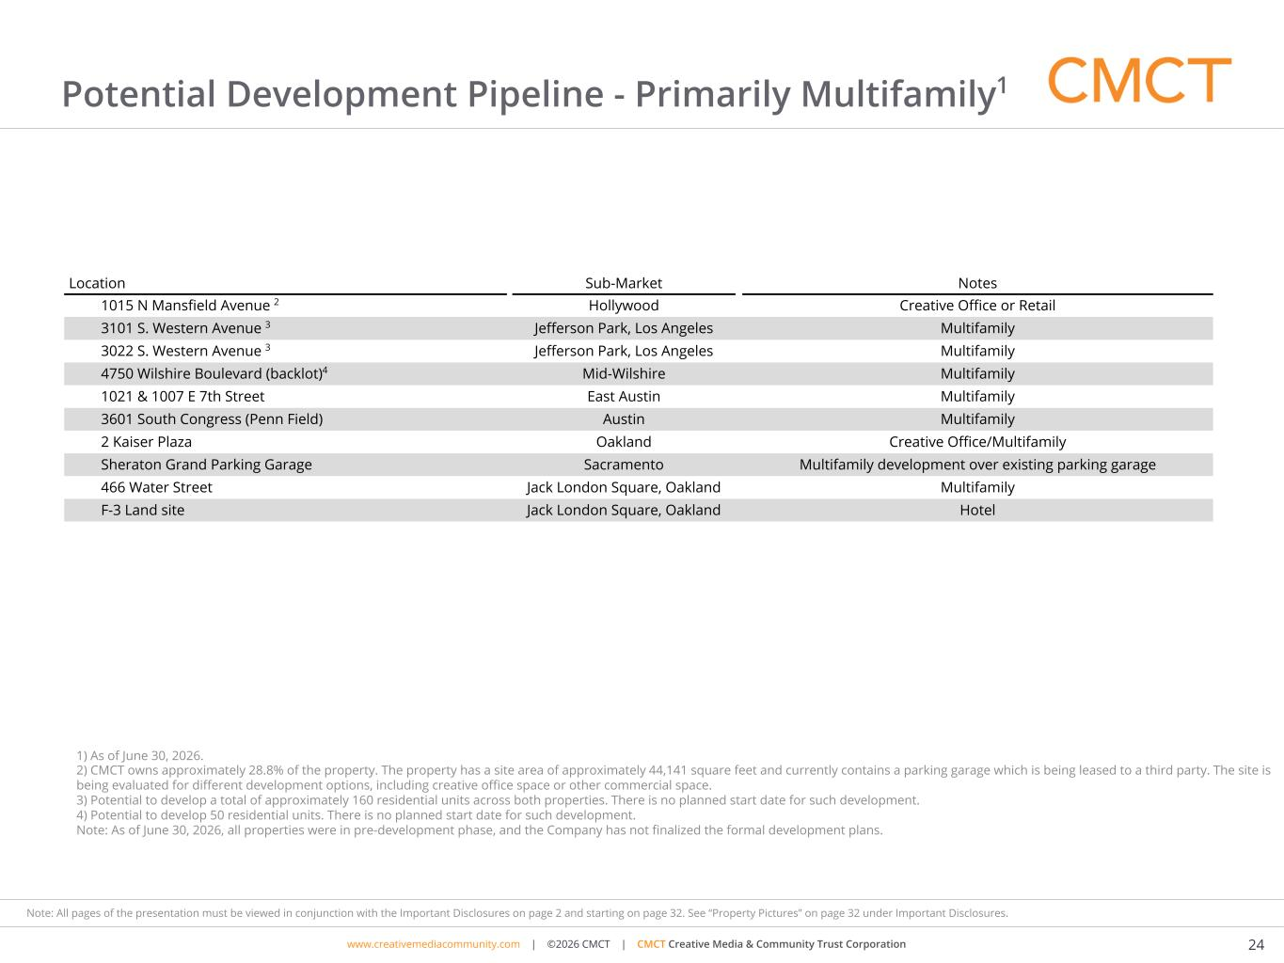
www.cimgroup.com | ©2018 CIM Group | TRADE SECRET / CONFIDENTIAL INFORMATIONwww.creativemediacommunity.com | ©2026 CMCT | CMCT Creative Media & Community Trust Corporation 24 Note: All pages of the presentation must be viewed in conjunction with the Important Disclosures on page 2 and starting on page 32. See “Property Pictures” on page 32 under Important Disclosures. Potential Development Pipeline - Primarily Multifamily1 Location Sub-Market Notes 1015 N Mansfield Avenue 2 Hollywood Creative Office or Retail 3101 S. Western Avenue 3 Jefferson Park, Los Angeles Multifamily 3022 S. Western Avenue 3 Jefferson Park, Los Angeles Multifamily 4750 Wilshire Boulevard (backlot)4 Mid-Wilshire Multifamily 1021 & 1007 E 7th Street East Austin Multifamily 3601 South Congress (Penn Field) Austin Multifamily 2 Kaiser Plaza Oakland Creative Office/Multifamily Sheraton Grand Parking Garage Sacramento Multifamily development over existing parking garage 466 Water Street Jack London Square, Oakland Multifamily F-3 Land site Jack London Square, Oakland Hotel 1) As of June 30, 2026. 2) CMCT owns approximately 28.8% of the property. The property has a site area of approximately 44,141 square feet and currently contains a parking garage which is being leased to a third party. The site is being evaluated for different development options, including creative office space or other commercial space. 3) Potential to develop a total of approximately 160 residential units across both properties. There is no planned start date for such development. 4) Potential to develop 50 residential units. There is no planned start date for such development. Note: As of June 30, 2026, all properties were in pre-development phase, and the Company has not finalized the formal development plans.

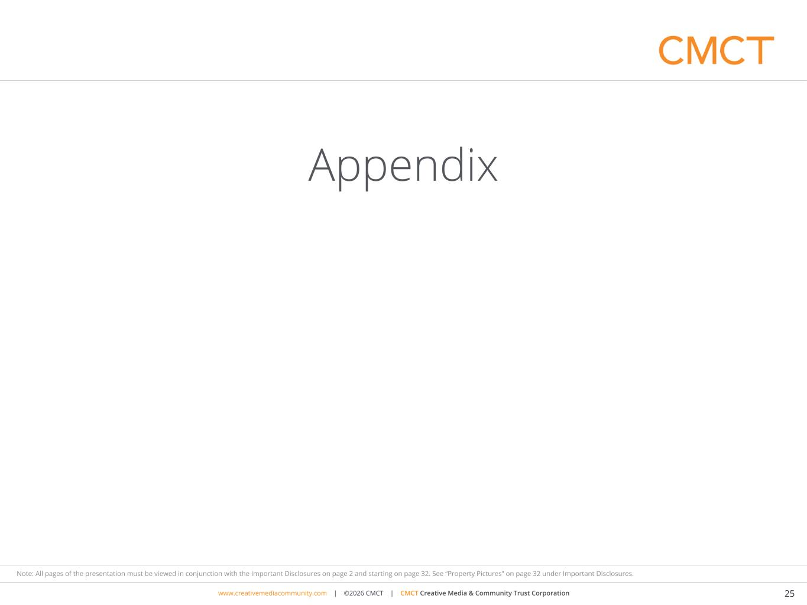
www.cimgroup.com | ©2018 CIM Group | TRADE SECRET / CONFIDENTIAL INFORMATIONwww.creativemediacommunity.com | ©2026 CMCT | CMCT Creative Media & Community Trust Corporation 25 Note: All pages of the presentation must be viewed in conjunction with the Important Disclosures on page 2 and starting on page 32. See “Property Pictures” on page 32 under Important Disclosures. Appendix

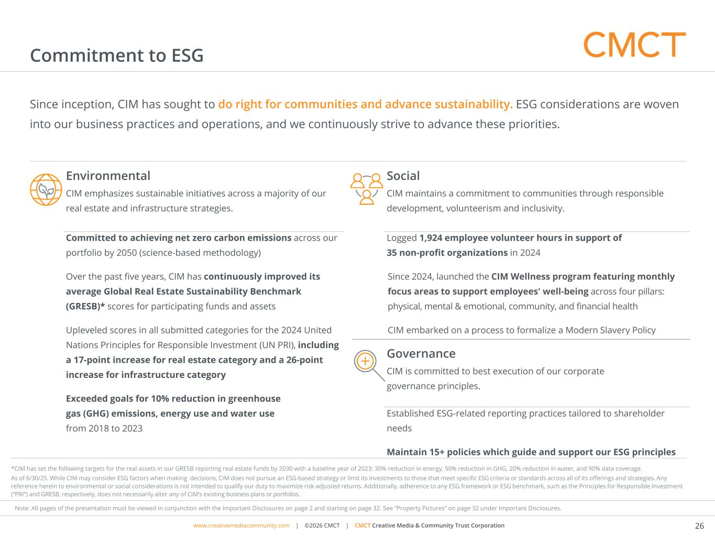
www.cimgroup.com | ©2018 CIM Group | TRADE SECRET / CONFIDENTIAL INFORMATIONwww.creativemediacommunity.com | ©2026 CMCT | CMCT Creative Media & Community Trust Corporation 26 Note: All pages of the presentation must be viewed in conjunction with the Important Disclosures on page 2 and starting on page 32. See “Property Pictures” on page 32 under Important Disclosures. Commitment to ESG Since inception, CIM has sought to do right for communities and advance sustainability. ESG considerations are woven into our business practices and operations, and we continuously strive to advance these priorities. Environmental CIM emphasizes sustainable initiatives across a majority of our real estate and infrastructure strategies. Committed to achieving net zero carbon emissions across our portfolio by 2050 (science-based methodology) Over the past five years, CIM has continuously improved its average Global Real Estate Sustainability Benchmark (GRESB)* scores for participating funds and assets Upleveled scores in all submitted categories for the 2024 United Nations Principles for Responsible Investment (UN PRI), including a 17-point increase for real estate category and a 26-point increase for infrastructure category Exceeded goals for 10% reduction in greenhouse gas (GHG) emissions, energy use and water use from 2018 to 2023 Social CIM maintains a commitment to communities through responsible development, volunteerism and inclusivity. Logged 1,924 employee volunteer hours in support of 35 non-profit organizations in 2024 Since 2024, launched the CIM Wellness program featuring monthly focus areas to support employees' well-being across four pillars: physical, mental & emotional, community, and financial health CIM embarked on a process to formalize a Modern Slavery Policy Governance CIM is committed to best execution of our corporate governance principles. Established ESG-related reporting practices tailored to shareholder needs Maintain 15+ policies which guide and support our ESG principles *CIM has set the following targets for the real assets in our GRESB reporting real estate funds by 2030 with a baseline year of 2023: 30% reduction in energy, 50% reduction in GHG, 20% reduction in water, and 90% data coverage. As of 6/30/25. While CIM may consider ESG factors when making decisions, CIM does not pursue an ESG-based strategy or limit its investments to those that meet specific ESG criteria or standards across all of its offerings and strategies. Any reference herein to environmental or social considerations is not intended to qualify our duty to maximize risk-adjusted returns. Additionally, adherence to any ESG framework or ESG benchmark, such as the Principles for Responsible Investment (“PRI”) and GRESB, respectively, does not necessarily alter any of CIM’s existing business plans or portfolios.

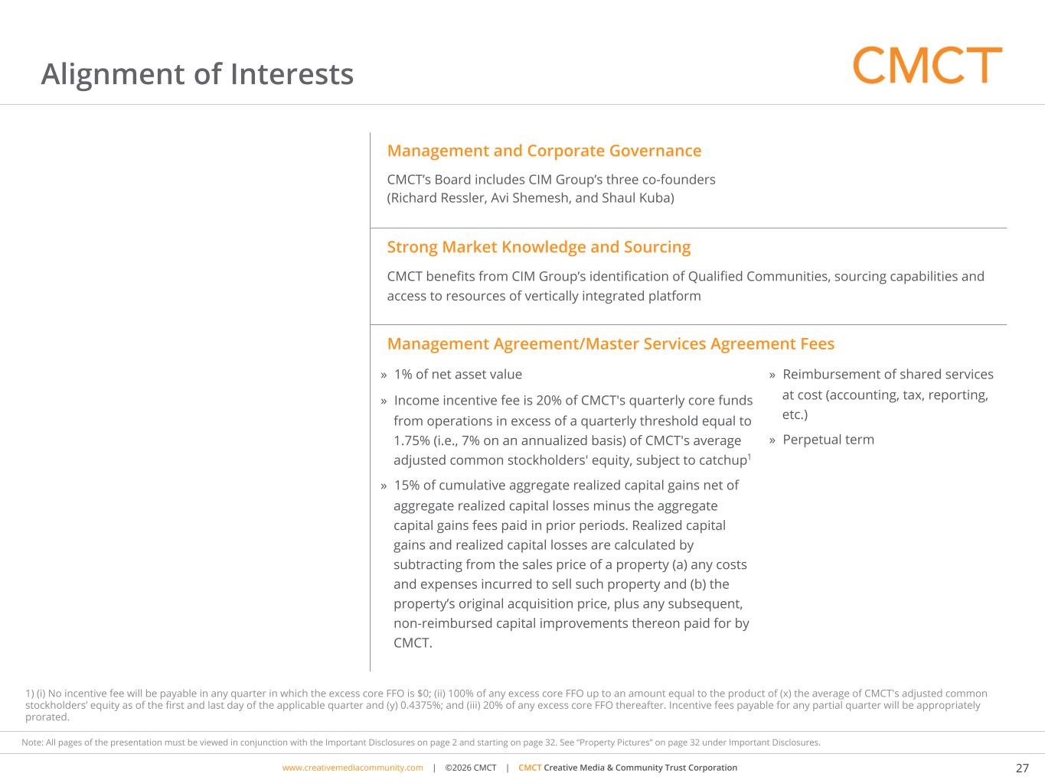
www.cimgroup.com | ©2018 CIM Group | TRADE SECRET / CONFIDENTIAL INFORMATIONwww.creativemediacommunity.com | ©2026 CMCT | CMCT Creative Media & Community Trust Corporation 27 Note: All pages of the presentation must be viewed in conjunction with the Important Disclosures on page 2 and starting on page 32. See “Property Pictures” on page 32 under Important Disclosures. Alignment of Interests 1) (i) No incentive fee will be payable in any quarter in which the excess core FFO is $0; (ii) 100% of any excess core FFO up to an amount equal to the product of (x) the average of CMCT's adjusted common stockholders’ equity as of the first and last day of the applicable quarter and (y) 0.4375%; and (iii) 20% of any excess core FFO thereafter. Incentive fees payable for any partial quarter will be appropriately prorated. Management and Corporate Governance CMCT’s Board includes CIM Group’s three co-founders (Richard Ressler, Avi Shemesh, and Shaul Kuba) Strong Market Knowledge and Sourcing CMCT benefits from CIM Group’s identification of Qualified Communities, sourcing capabilities and access to resources of vertically integrated platform Management Agreement/Master Services Agreement Fees » 1% of net asset value » Income incentive fee is 20% of CMCT's quarterly core funds from operations in excess of a quarterly threshold equal to 1.75% (i.e., 7% on an annualized basis) of CMCT's average adjusted common stockholders' equity, subject to catchup1 » 15% of cumulative aggregate realized capital gains net of aggregate realized capital losses minus the aggregate capital gains fees paid in prior periods. Realized capital gains and realized capital losses are calculated by subtracting from the sales price of a property (a) any costs and expenses incurred to sell such property and (b) the property’s original acquisition price, plus any subsequent, non-reimbursed capital improvements thereon paid for by CMCT. » Reimbursement of shared services at cost (accounting, tax, reporting, etc.) » Perpetual term

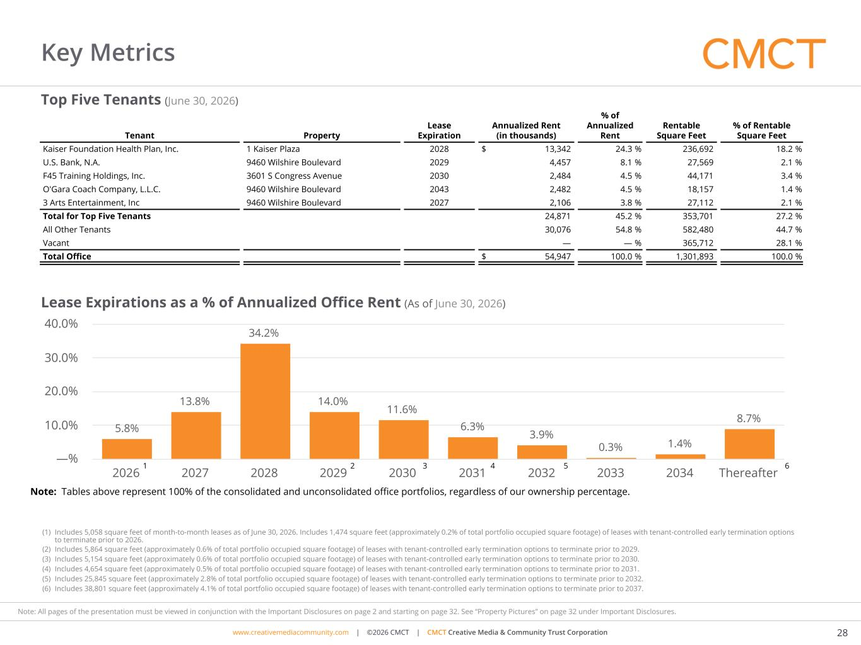
www.cimgroup.com | ©2018 CIM Group | TRADE SECRET / CONFIDENTIAL INFORMATIONwww.creativemediacommunity.com | ©2026 CMCT | CMCT Creative Media & Community Trust Corporation 28 Note: All pages of the presentation must be viewed in conjunction with the Important Disclosures on page 2 and starting on page 32. See “Property Pictures” on page 32 under Important Disclosures. Key Metrics Lease Expirations as a % of Annualized Office Rent (As of June 30, 2026) Top Five Tenants (June 30, 2026) 5.8% 13.8% 34.2% 14.0% 11.6% 6.3% 3.9% 0.3% 1.4% 8.7% 2026 2027 2028 2029 2030 2031 2032 2033 2034 Thereafter —% 10.0% 20.0% 30.0% 40.0% Tenant Property Lease Expiration Annualized Rent (in thousands) % of Annualized Rent Rentable Square Feet % of Rentable Square Feet Kaiser Foundation Health Plan, Inc. 1 Kaiser Plaza 2028 $ 13,342 24.3 % 236,692 18.2 % U.S. Bank, N.A. 9460 Wilshire Boulevard 2029 4,457 8.1 % 27,569 2.1 % F45 Training Holdings, Inc. 3601 S Congress Avenue 2030 2,484 4.5 % 44,171 3.4 % O'Gara Coach Company, L.L.C. 9460 Wilshire Boulevard 2043 2,482 4.5 % 18,157 1.4 % 3 Arts Entertainment, Inc 9460 Wilshire Boulevard 2027 2,106 3.8 % 27,112 2.1 % Total for Top Five Tenants 24,871 45.2 % 353,701 27.2 % All Other Tenants 30,076 54.8 % 582,480 44.7 % Vacant — — % 365,712 28.1 % Total Office $ 54,947 100.0 % 1,301,893 100.0 % 1 Note: Tables above represent 100% of the consolidated and unconsolidated office portfolios, regardless of our ownership percentage. 2 43 5 6 (1) Includes 5,058 square feet of month-to-month leases as of June 30, 2026. Includes 1,474 square feet (approximately 0.2% of total portfolio occupied square footage) of leases with tenant-controlled early termination options to terminate prior to 2026. (2) Includes 5,864 square feet (approximately 0.6% of total portfolio occupied square footage) of leases with tenant-controlled early termination options to terminate prior to 2029. (3) Includes 5,154 square feet (approximately 0.6% of total portfolio occupied square footage) of leases with tenant-controlled early termination options to terminate prior to 2030. (4) Includes 4,654 square feet (approximately 0.5% of total portfolio occupied square footage) of leases with tenant-controlled early termination options to terminate prior to 2031. (5) Includes 25,845 square feet (approximately 2.8% of total portfolio occupied square footage) of leases with tenant-controlled early termination options to terminate prior to 2032. (6) Includes 38,801 square feet (approximately 4.1% of total portfolio occupied square footage) of leases with tenant-controlled early termination options to terminate prior to 2037.

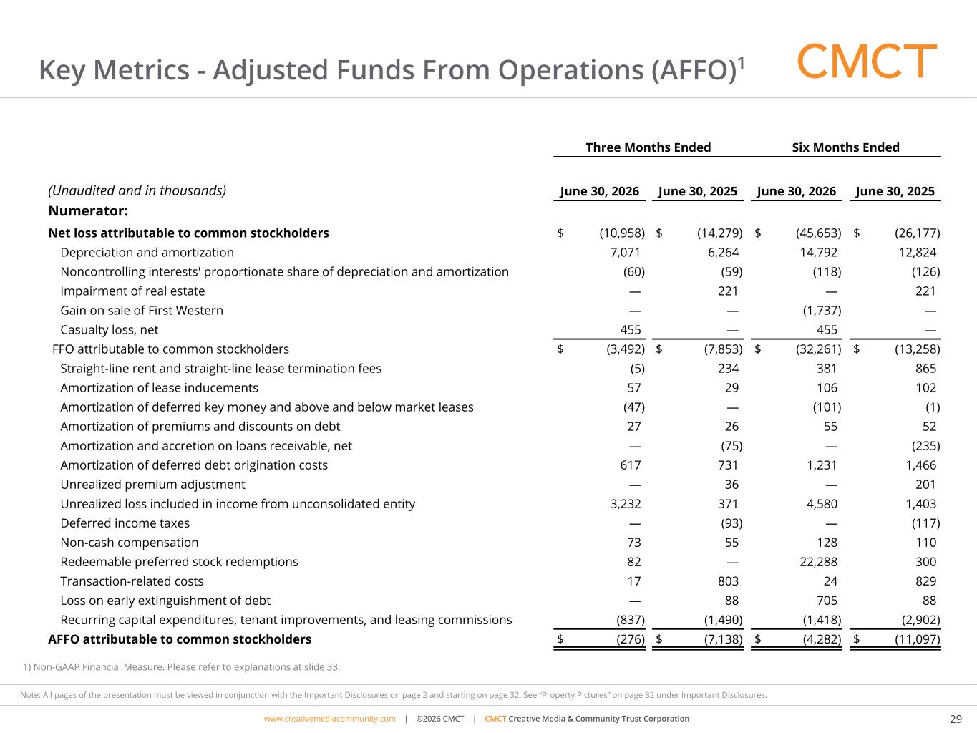
www.cimgroup.com | ©2018 CIM Group | TRADE SECRET / CONFIDENTIAL INFORMATIONwww.creativemediacommunity.com | ©2026 CMCT | CMCT Creative Media & Community Trust Corporation 29 Note: All pages of the presentation must be viewed in conjunction with the Important Disclosures on page 2 and starting on page 32. See “Property Pictures” on page 32 under Important Disclosures. Key Metrics - Adjusted Funds From Operations (AFFO)1 1) Non-GAAP Financial Measure. Please refer to explanations at slide 33. Three Months Ended Six Months Ended (Unaudited and in thousands) June 30, 2026 June 30, 2025 June 30, 2026 June 30, 2025 Numerator: Net loss attributable to common stockholders $ (10,958) $ (14,279) $ (45,653) $ (26,177) Depreciation and amortization 7,071 6,264 14,792 12,824 Noncontrolling interests' proportionate share of depreciation and amortization (60) (59) (118) (126) Impairment of real estate — 221 — 221 Gain on sale of First Western — — (1,737) — Casualty loss, net 455 — 455 — FFO attributable to common stockholders $ (3,492) $ (7,853) $ (32,261) $ (13,258) Straight-line rent and straight-line lease termination fees (5) 234 381 865 Amortization of lease inducements 57 29 106 102 Amortization of deferred key money and above and below market leases (47) — (101) (1) Amortization of premiums and discounts on debt 27 26 55 52 Amortization and accretion on loans receivable, net — (75) — (235) Amortization of deferred debt origination costs 617 731 1,231 1,466 Unrealized premium adjustment — 36 — 201 Unrealized loss included in income from unconsolidated entity 3,232 371 4,580 1,403 Deferred income taxes — (93) — (117) Non-cash compensation 73 55 128 110 Redeemable preferred stock redemptions 82 — 22,288 300 Transaction-related costs 17 803 24 829 Loss on early extinguishment of debt — 88 705 88 Recurring capital expenditures, tenant improvements, and leasing commissions (837) (1,490) (1,418) (2,902) AFFO attributable to common stockholders $ (276) $ (7,138) $ (4,282) $ (11,097)

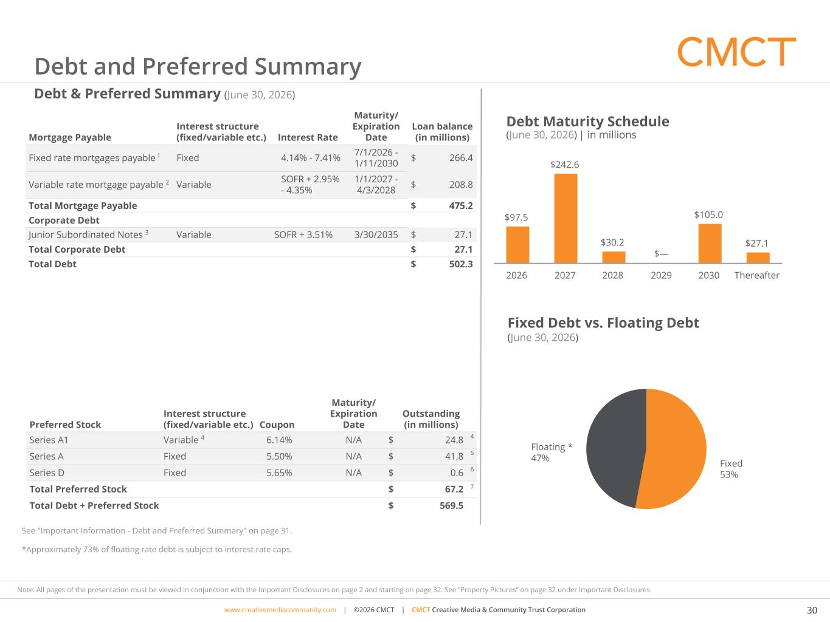
www.cimgroup.com | ©2018 CIM Group | TRADE SECRET / CONFIDENTIAL INFORMATIONwww.creativemediacommunity.com | ©2026 CMCT | CMCT Creative Media & Community Trust Corporation 30 Note: All pages of the presentation must be viewed in conjunction with the Important Disclosures on page 2 and starting on page 32. See “Property Pictures” on page 32 under Important Disclosures. $97.5 $242.6 $30.2 $— $105.0 $27.1 2026 2027 2028 2029 2030 Thereafter Debt & Preferred Summary (June 30, 2026) Fixed 53% Floating * 47% Debt Maturity Schedule (June 30, 2026) | in millions Fixed Debt vs. Floating Debt (June 30, 2026) Mortgage Payable Interest structure (fixed/variable etc.) Interest Rate Maturity/ Expiration Date Loan balance (in millions) Fixed rate mortgages payable 1 Fixed 4.14% - 7.41% 7/1/2026 - 1/11/2030 $ 266.4 Variable rate mortgage payable 2 Variable SOFR + 2.95% - 4.35% 1/1/2027 - 4/3/2028 $ 208.8 Total Mortgage Payable $ 475.2 Corporate Debt Junior Subordinated Notes 3 Variable SOFR + 3.51% 3/30/2035 $ 27.1 Total Corporate Debt $ 27.1 Total Debt $ 502.3 Preferred Stock Interest structure (fixed/variable etc.) Coupon Maturity/ Expiration Date Outstanding (in millions) Series A1 Variable 4 6.14% N/A $ 24.8 4 Series A Fixed 5.50% N/A $ 41.8 5 Series D Fixed 5.65% N/A $ 0.6 6 Total Preferred Stock $ 67.2 7 Total Debt + Preferred Stock $ 569.5 Debt and Preferred Summary See "Important Information - Debt and Preferred Summary" on page 31. *Approximately 73% of floating rate debt is subject to interest rate caps.

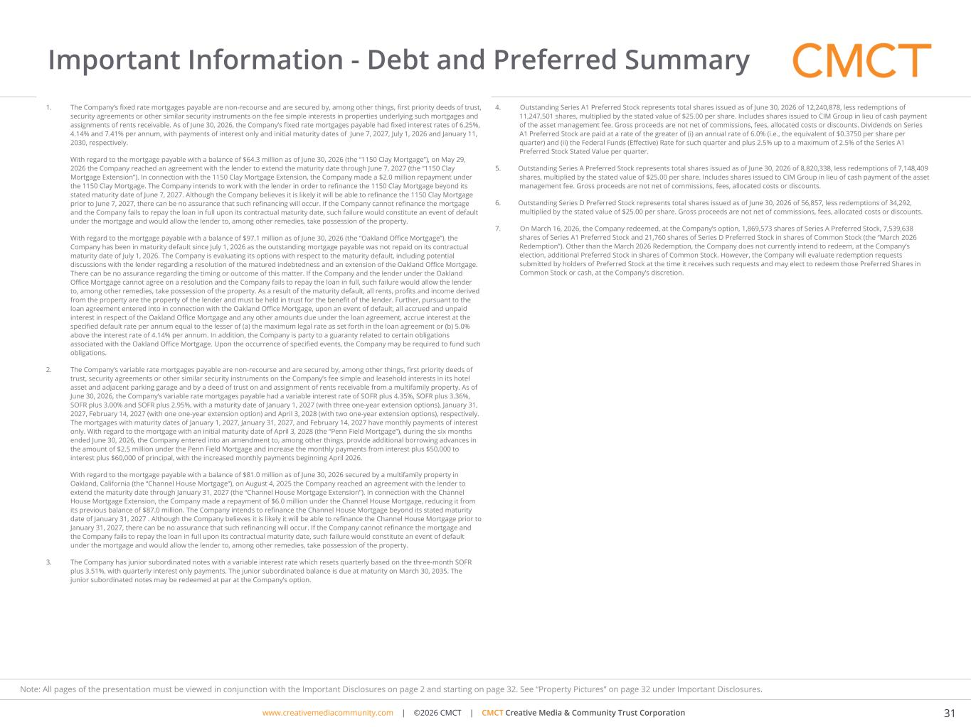
www.cimgroup.com | ©2018 CIM Group | TRADE SECRET / CONFIDENTIAL INFORMATIONwww.creativemediacommunity.com | ©2026 CMCT | CMCT Creative Media & Community Trust Corporation 31 Note: All pages of the presentation must be viewed in conjunction with the Important Disclosures on page 2 and starting on page 32. See “Property Pictures” on page 32 under Important Disclosures. Important Information - Debt and Preferred Summary 4. Outstanding Series A1 Preferred Stock represents total shares issued as of June 30, 2026 of 12,240,878, less redemptions of 11,247,501 shares, multiplied by the stated value of $25.00 per share. Includes shares issued to CIM Group in lieu of cash payment of the asset management fee. Gross proceeds are not net of commissions, fees, allocated costs or discounts. Dividends on Series A1 Preferred Stock are paid at a rate of the greater of (i) an annual rate of 6.0% (i.e., the equivalent of $0.3750 per share per quarter) and (ii) the Federal Funds (Effective) Rate for such quarter and plus 2.5% up to a maximum of 2.5% of the Series A1 Preferred Stock Stated Value per quarter. 5. Outstanding Series A Preferred Stock represents total shares issued as of June 30, 2026 of 8,820,338, less redemptions of 7,148,409 shares, multiplied by the stated value of $25.00 per share. Includes shares issued to CIM Group in lieu of cash payment of the asset management fee. Gross proceeds are not net of commissions, fees, allocated costs or discounts. 6. Outstanding Series D Preferred Stock represents total shares issued as of June 30, 2026 of 56,857, less redemptions of 34,292, multiplied by the stated value of $25.00 per share. Gross proceeds are not net of commissions, fees, allocated costs or discounts. 7. On March 16, 2026, the Company redeemed, at the Company’s option, 1,869,573 shares of Series A Preferred Stock, 7,539,638 shares of Series A1 Preferred Stock and 21,760 shares of Series D Preferred Stock in shares of Common Stock (the “March 2026 Redemption”). Other than the March 2026 Redemption, the Company does not currently intend to redeem, at the Company’s election, additional Preferred Stock in shares of Common Stock. However, the Company will evaluate redemption requests submitted by holders of Preferred Stock at the time it receives such requests and may elect to redeem those Preferred Shares in Common Stock or cash, at the Company’s discretion. 1. The Company’s fixed rate mortgages payable are non-recourse and are secured by, among other things, first priority deeds of trust, security agreements or other similar security instruments on the fee simple interests in properties underlying such mortgages and assignments of rents receivable. As of June 30, 2026, the Company’s fixed rate mortgages payable had fixed interest rates of 6.25%, 4.14% and 7.41% per annum, with payments of interest only and initial maturity dates of June 7, 2027, July 1, 2026 and January 11, 2030, respectively. With regard to the mortgage payable with a balance of $64.3 million as of June 30, 2026 (the “1150 Clay Mortgage”), on May 29, 2026 the Company reached an agreement with the lender to extend the maturity date through June 7, 2027 (the “1150 Clay Mortgage Extension”). In connection with the 1150 Clay Mortgage Extension, the Company made a $2.0 million repayment under the 1150 Clay Mortgage. The Company intends to work with the lender in order to refinance the 1150 Clay Mortgage beyond its stated maturity date of June 7, 2027. Although the Company believes it is likely it will be able to refinance the 1150 Clay Mortgage prior to June 7, 2027, there can be no assurance that such refinancing will occur. If the Company cannot refinance the mortgage and the Company fails to repay the loan in full upon its contractual maturity date, such failure would constitute an event of default under the mortgage and would allow the lender to, among other remedies, take possession of the property. With regard to the mortgage payable with a balance of $97.1 million as of June 30, 2026 (the “Oakland Office Mortgage”), the Company has been in maturity default since July 1, 2026 as the outstanding mortgage payable was not repaid on its contractual maturity date of July 1, 2026. The Company is evaluating its options with respect to the maturity default, including potential discussions with the lender regarding a resolution of the matured indebtedness and an extension of the Oakland Office Mortgage. There can be no assurance regarding the timing or outcome of this matter. If the Company and the lender under the Oakland Office Mortgage cannot agree on a resolution and the Company fails to repay the loan in full, such failure would allow the lender to, among other remedies, take possession of the property. As a result of the maturity default, all rents, profits and income derived from the property are the property of the lender and must be held in trust for the benefit of the lender. Further, pursuant to the loan agreement entered into in connection with the Oakland Office Mortgage, upon an event of default, all accrued and unpaid interest in respect of the Oakland Office Mortgage and any other amounts due under the loan agreement, accrue interest at the specified default rate per annum equal to the lesser of (a) the maximum legal rate as set forth in the loan agreement or (b) 5.0% above the interest rate of 4.14% per annum. In addition, the Company is party to a guaranty related to certain obligations associated with the Oakland Office Mortgage. Upon the occurrence of specified events, the Company may be required to fund such obligations. 2. The Company’s variable rate mortgages payable are non-recourse and are secured by, among other things, first priority deeds of trust, security agreements or other similar security instruments on the Company’s fee simple and leasehold interests in its hotel asset and adjacent parking garage and by a deed of trust on and assignment of rents receivable from a multifamily property. As of June 30, 2026, the Company’s variable rate mortgages payable had a variable interest rate of SOFR plus 4.35%, SOFR plus 3.36%, SOFR plus 3.00% and SOFR plus 2.95%, with a maturity date of January 1, 2027 (with three one-year extension options), January 31, 2027, February 14, 2027 (with one one-year extension option) and April 3, 2028 (with two one-year extension options), respectively. The mortgages with maturity dates of January 1, 2027, January 31, 2027, and February 14, 2027 have monthly payments of interest only. With regard to the mortgage with an initial maturity date of April 3, 2028 (the “Penn Field Mortgage”), during the six months ended June 30, 2026, the Company entered into an amendment to, among other things, provide additional borrowing advances in the amount of $2.5 million under the Penn Field Mortgage and increase the monthly payments from interest plus $50,000 to interest plus $60,000 of principal, with the increased monthly payments beginning April 2026. With regard to the mortgage payable with a balance of $81.0 million as of June 30, 2026 secured by a multifamily property in Oakland, California (the “Channel House Mortgage”), on August 4, 2025 the Company reached an agreement with the lender to extend the maturity date through January 31, 2027 (the “Channel House Mortgage Extension”). In connection with the Channel House Mortgage Extension, the Company made a repayment of $6.0 million under the Channel House Mortgage, reducing it from its previous balance of $87.0 million. The Company intends to refinance the Channel House Mortgage beyond its stated maturity date of January 31, 2027 . Although the Company believes it is likely it will be able to refinance the Channel House Mortgage prior to January 31, 2027, there can be no assurance that such refinancing will occur. If the Company cannot refinance the mortgage and the Company fails to repay the loan in full upon its contractual maturity date, such failure would constitute an event of default under the mortgage and would allow the lender to, among other remedies, take possession of the property. 3. The Company has junior subordinated notes with a variable interest rate which resets quarterly based on the three-month SOFR plus 3.51%, with quarterly interest only payments. The junior subordinated balance is due at maturity on March 30, 2035. The junior subordinated notes may be redeemed at par at the Company’s option.

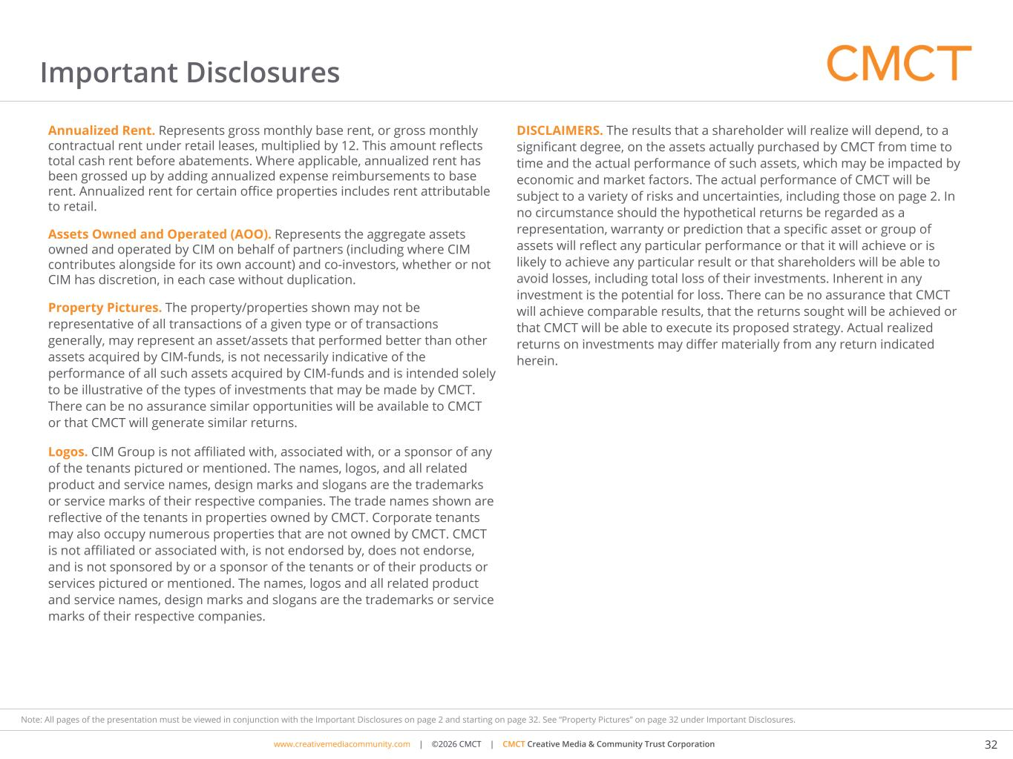
www.cimgroup.com | ©2018 CIM Group | TRADE SECRET / CONFIDENTIAL INFORMATIONwww.creativemediacommunity.com | ©2026 CMCT | CMCT Creative Media & Community Trust Corporation 32 Note: All pages of the presentation must be viewed in conjunction with the Important Disclosures on page 2 and starting on page 32. See “Property Pictures” on page 32 under Important Disclosures. Important Disclosures Annualized Rent. Represents gross monthly base rent, or gross monthly contractual rent under retail leases, multiplied by 12. This amount reflects total cash rent before abatements. Where applicable, annualized rent has been grossed up by adding annualized expense reimbursements to base rent. Annualized rent for certain office properties includes rent attributable to retail. Assets Owned and Operated (AOO). Represents the aggregate assets owned and operated by CIM on behalf of partners (including where CIM contributes alongside for its own account) and co-investors, whether or not CIM has discretion, in each case without duplication. Property Pictures. The property/properties shown may not be representative of all transactions of a given type or of transactions generally, may represent an asset/assets that performed better than other assets acquired by CIM-funds, is not necessarily indicative of the performance of all such assets acquired by CIM-funds and is intended solely to be illustrative of the types of investments that may be made by CMCT. There can be no assurance similar opportunities will be available to CMCT or that CMCT will generate similar returns. Logos. CIM Group is not affiliated with, associated with, or a sponsor of any of the tenants pictured or mentioned. The names, logos, and all related product and service names, design marks and slogans are the trademarks or service marks of their respective companies. The trade names shown are reflective of the tenants in properties owned by CMCT. Corporate tenants may also occupy numerous properties that are not owned by CMCT. CMCT is not affiliated or associated with, is not endorsed by, does not endorse, and is not sponsored by or a sponsor of the tenants or of their products or services pictured or mentioned. The names, logos and all related product and service names, design marks and slogans are the trademarks or service marks of their respective companies. DISCLAIMERS. The results that a shareholder will realize will depend, to a significant degree, on the assets actually purchased by CMCT from time to time and the actual performance of such assets, which may be impacted by economic and market factors. The actual performance of CMCT will be subject to a variety of risks and uncertainties, including those on page 2. In no circumstance should the hypothetical returns be regarded as a representation, warranty or prediction that a specific asset or group of assets will reflect any particular performance or that it will achieve or is likely to achieve any particular result or that shareholders will be able to avoid losses, including total loss of their investments. Inherent in any investment is the potential for loss. There can be no assurance that CMCT will achieve comparable results, that the returns sought will be achieved or that CMCT will be able to execute its proposed strategy. Actual realized returns on investments may differ materially from any return indicated herein.

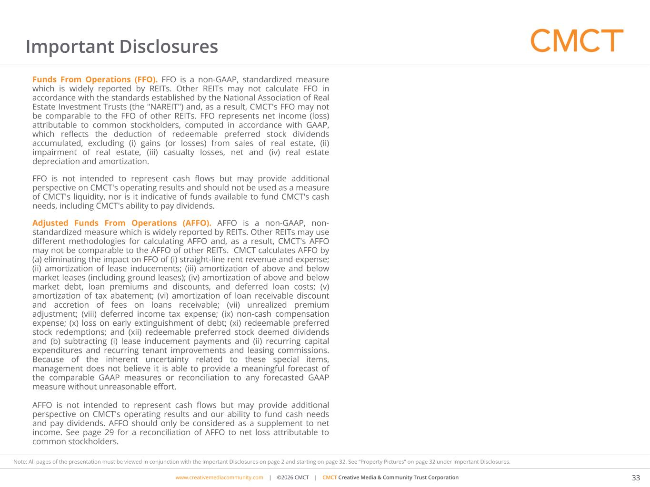
www.cimgroup.com | ©2018 CIM Group | TRADE SECRET / CONFIDENTIAL INFORMATIONwww.creativemediacommunity.com | ©2026 CMCT | CMCT Creative Media & Community Trust Corporation 33 Note: All pages of the presentation must be viewed in conjunction with the Important Disclosures on page 2 and starting on page 32. See “Property Pictures” on page 32 under Important Disclosures. Important Disclosures Funds From Operations (FFO). FFO is a non-GAAP, standardized measure which is widely reported by REITs. Other REITs may not calculate FFO in accordance with the standards established by the National Association of Real Estate Investment Trusts (the "NAREIT") and, as a result, CMCT's FFO may not be comparable to the FFO of other REITs. FFO represents net income (loss) attributable to common stockholders, computed in accordance with GAAP, which reflects the deduction of redeemable preferred stock dividends accumulated, excluding (i) gains (or losses) from sales of real estate, (ii) impairment of real estate, (iii) casualty losses, net and (iv) real estate depreciation and amortization. FFO is not intended to represent cash flows but may provide additional perspective on CMCT's operating results and should not be used as a measure of CMCT's liquidity, nor is it indicative of funds available to fund CMCT's cash needs, including CMCT's ability to pay dividends. Adjusted Funds From Operations (AFFO). AFFO is a non-GAAP, non- standardized measure which is widely reported by REITs. Other REITs may use different methodologies for calculating AFFO and, as a result, CMCT's AFFO may not be comparable to the AFFO of other REITs. CMCT calculates AFFO by (a) eliminating the impact on FFO of (i) straight-line rent revenue and expense; (ii) amortization of lease inducements; (iii) amortization of above and below market leases (including ground leases); (iv) amortization of above and below market debt, loan premiums and discounts, and deferred loan costs; (v) amortization of tax abatement; (vi) amortization of loan receivable discount and accretion of fees on loans receivable; (vii) unrealized premium adjustment; (viii) deferred income tax expense; (ix) non-cash compensation expense; (x) loss on early extinguishment of debt; (xi) redeemable preferred stock redemptions; and (xii) redeemable preferred stock deemed dividends and (b) subtracting (i) lease inducement payments and (ii) recurring capital expenditures and recurring tenant improvements and leasing commissions. Because of the inherent uncertainty related to these special items, management does not believe it is able to provide a meaningful forecast of the comparable GAAP measures or reconciliation to any forecasted GAAP measure without unreasonable effort. AFFO is not intended to represent cash flows but may provide additional perspective on CMCT's operating results and our ability to fund cash needs and pay dividends. AFFO should only be considered as a supplement to net income. See page 29 for a reconciliation of AFFO to net loss attributable to common stockholders.

